**Applied Analytic Modelling**

**Group Project**

**A Predictive Model Approach to Elevate the Success of a Marketing Campaign**

**SAS Miner**

Submitted to

Prof. David Parent

Submitted by

**Bhawan Taneja (301415854)**

**Ishika Bhutani (301323447)**

**Nirmal Santhosh (301338999)**

**Riya Chaudhary (301329229)**

Contents

Introduction 3

Steps involved in the study: 4

Defining Business Problem 5

Filter Node 13

Data Partition 14

Decision Tree: 14

Random Forest………………………………………………………………………………………15

Boosted tree…………………………………………………………………………………………18

Regressions 21

Transform Variables Node 24

Recode (Replacement Node) 25

Regression Nodes: 27

Variable importance 31

NEURAL NETWORKS 33

Comparison of Neural Networks with Hidden Units. 40

Conclusion 42

Recommendations 43

# Introduction

This project involves the systematic study of a dataset where our team meticulously evaluated a business problem and explored multiple ways to solve the issue using SAS Enterprise Miner and Python. In the initial stage of the project, we identified the domain where we intended to address a business problem and subsequently, we analysed the major issues happening in the domain. We were particular about doing our study in the marketing domain as our group members have sufficient domain expertise and working knowledge. Few group members have strong industrial knowledge in the working of social media campaigns and since e-commerce and e-tailing are growing exponentially, we decided to go ahead with Marketing Campaigns and analytics and how we could leverage the power of data to tackle existing issues. Social media marketing campaigns, though used extensively, possess significant issues when it comes to their practical ability to achieve objectives.

The primary issue is with the target customers or intended participants who should receive the campaign. Prima facie it tends to feel that those who are associated with the brand or have shopped for a particular product should receive the campaign. However, there are obvious reasons to believe otherwise. Social media statistics quote that around 38.5% of marketing campaigns are delivered to the wrong target or won't reap any significant benefits to the enterprise. (Economist,2022) This is something detrimental when the company invests heavily in marketing campaigns to increase awareness or brand value. Most often brands see social media campaigns as a way to do brand positioning, introduce a new product, or even test marketing. Therefore, social media campaigns should deliver the value marketers expect for both the short and long term. Along with this, another persistent problem is the analysis of marketing campaigns.

Marketeers often analyze the final data available after the execution of a campaign However, most of them are ignorant about the deep analysis of marketing campaigns where they get strategic insights about the data analysis, where they went wrong, and what could be done in order to make the marketing campaign efficient. Our project at its final phase portrays a detailed analytical study that throws light on what factors should be kept in mind while executing a campaign, whether our gut feelings are always correct, or whether should we dissect data to find out more interesting information.

This project begins with the analysis of data that we have used for this project. It involves a critical examination of each and all variables and decisions on whether the variables are considered as inputs for the study or whether it is rejected, if that’s the case why exactly we have not included certain variables. Going forward, the project throws light on various aspects taken into consideration while deploying a model and the technical explanation of the same. Later, we will define different models such as decision trees, regression, and neural networks and see the analysis of each model thus juxtaposing various models to evaluate among each other and find the best one out of them. All models are substantiated by relevant screenshots, technical analysis, and interpretations such that we would be able to compare and contrast the applications of different models simultaneously. This report tries to articulate findings in a much easier manner such that a layman could understand the study and comprehend things for their understanding. This project also tries to use various functionalities of SAS Enterprise Miner and Python such that the report gives greater emphasis to SAS Miner as an analytical tool for solving real-time issues with ease and greater efficiency. However, the study we conducted is restricted to the people who spend not more than 1000$ on wines in two years.

# Steps involved in the study:

This study involves a sequential process where we go deeply about various models of study and their possible interpretations. We have defined a sequential process for our study to make it comprehensive and aligned with the report requirements. Project phases are enumerated as follows:

1. **Define the business problem**: In this stage, we will define our business problem and illustrate what exactly we are trying to address. This stage demonstrates how our study is focused on marketing campaigns and its influence on the company’s revenue as well as brand value.

**2.** **Data Collection and Preparation:** Here, we will collect the relevant data for our study from a reliable source and check its authenticity. This is a critical stage as it involves collecting the data, checking whether the inputs are relevant, identifying data redundancy and irrelevancy, transforming the data for model deployment, etc. For our study, we collected data from kaggle.com.

**3.** **Exploratory Data Analysis:** Here we explore the dataset and understand the data, identify missing values, and do analysis to identify the variables that help us in the analytical study. Exploratory Data Analysis helps us to understand the data requirements necessary for the study. Variable selection and Transformations are run in conjunction with this. We perform EDA using both SAS Enterprise Miner and Python to gain comprehensive insights into the data.

**4.** **Model Building:** In this stage, we will build the model necessary for our study. In this case, we will build multiple models as per the requirement of the report such as Decision Trees, Regression models, and Neural Networks. Model building is carried out using both SAS Enterprise Miner and Python to compare the performance and efficacy of models in different environments.

**5.** **Model Evaluation:** The dataset is divided into training and validation to do model performance evaluation. Training dataset is used for preliminary model fitting whereas validation data is used for monitoring and running free model parameters during estimation. In order to ensure robust performance metrics from both tools, we use both SAS Enterprise Miner and Python to evaluate the models.

**6.** **Model Execution/Deployment:** Here, we run the model we built for detailed analysis. Once a model is executed, we will be able to do model interpretations. Python allows us to cross-validate results and interpretations.

**7.** **Monitor and Evaluation:**  It is not always necessary that we are satisfied with the model results. A model result will help us to understand whether we need to make any changes as per business requirements. SAS Miner provides us the opportunity to make changes to make the model execution more reliable. We have made use of Python’s flexibility that allows for iterative improvements and fine-tuning models.

**8.** **Documentation:** A detailed documentation has been made about the various model results such that it gives us the relevant information for future reference as well.

# Defining Business Problem

The business problem is to develop a predictive model that is built on a comprehensive study of the impact of social media campaigns and investigating methods to improve campaign effectiveness and ROI. The model would strategically target high-value customer segments, increasing the likelihood of positive responses and purchases, and ultimately maximizing the profit generated from the next Marketing Campaign.

The Variables and their Roles

As mentioned before, this report evaluates the effectiveness of marketing campaigns. This study involves a systematic review of the marketing campaign, its implementation, optimization, and the way the results are interpreted. Here, we will enumerate the various variables that were in the preliminary dataset and the final selection of variables after rejection as well:

**Variables:**

AcceptedCmp1 - 1 if customer accepted the offer in the 1st campaign, 0 otherwise,

AcceptedCmp2 - 1 if customer accepted the offer in the 2nd campaign, 0 otherwise,

AcceptedCmp3 - 1 if customer accepted the offer in the 3rd campaign, 0 otherwise,

AcceptedCmp4 - 1 if customer accepted the offer in the 4th campaign, 0 otherwise,

AcceptedCmp5 - 1 if customer accepted the offer in the 5th campaign, 0 otherwise,

Response (target) - 1 if customer accepted the offer in the last campaign, 0 otherwise,

Complain - 1 if customer complained in the last 2 years.

DtCustomer - date of customer’s enrolment with the company.

Education - customer’s level of education

Marital - customer’s marital status

Kidhome - number of small children in customer’s household

Teenhome - number of teenagers in customer’s household

Income - customer’s yearly household income

MntFishProducts - the amount spent on fish products in the last 2 years

MntMeatProducts -the amount spent on meat products in the last 2 years

MntFruits - the amount spent on fruits products in the last 2 years

MntSweetProducts - the amount spent on sweet products in the last 2 years

MntWines - the amount spent on wine products in the last 2 years

MntGoldProds - the amount spent on gold products in the last 2 years

NumDealsPurchases - number of purchases made with discount

NumCatalogPurchases - number of purchases made using catalog

NumStorePurchases - number of purchases made directly in stores

NumWebPurchases - number of purchases made through company’s website

NumWebVisitsMonth - number of visits to company’s web site in the last month

Recency - number of days since the last purchase

**The total records or observations were 2240.**

**Findings from Python**

**Exploratory Data Analysis:**

1. **Missing Values Analysis:** We used ‘data.isnull().sum’ function to identify the missing values in our dataset. This step is crucial to ensure the data quality for further analysis. From our analysis, we found that majority columns have no missing values except for income which has 24 missing values.
2. **Descriptive Statistics:** Using ‘data.describe()’, we summarized the dataset, providing the insights into the central tendencies, dispersions, and shape of the data distribution. This summary includes count, mean, standard deviation, minimum and maximum values for each numerical column. For example, the mean income was calculated, along with the standard deviation which helps us understand the spread of the income data.

Most individuals in the dataset are middle aged, with varied income levels. There is a low incidence of children and teenagers in households. Spending on various products is diverse with significant differences in categories like wines, meat and fish. Wen visits and campaign acceptances show specific trends, with generally low engagement.

**Data Preparation:**

**Dropping Irrelevant Columns:** To streamline our analysis, we dropped columns that were not relevant to our study.

Using,data=data.drop(columns=["AcceptedCmp3","AcceptedCmp4","AcceptedCmp5","AcceptedCmp1","AcceptedCmp2","Dt_Customer","Z_CostContact","Z_Revenue"]), we removed columns related previous campaign responses and other non-essential data. This step helped in reducing the complexity of our dataset and focusing on the most relevant features.

**Visualisation:**

We have used ‘matplotlib’ and ‘seaborn’ to create the histograms and box plots which helped in understanding the distribution of variables and identifying outliers. A histogram of the income variable was plotted to visualise its distribution and a box plot was used to detect any outliers in the dataset.

The box plot below shows the visual summary of the distribution of income and other numerical variables in the dataset. The x-axis represents the various features, and the y-axis shows the values of these features. Each box in the plot represents the interquartile range of the data, with the line inside the box indicating the median. The **income** column shows a few outliers with very high values, which might need further investigation or handling to prevent skewing the analysis.

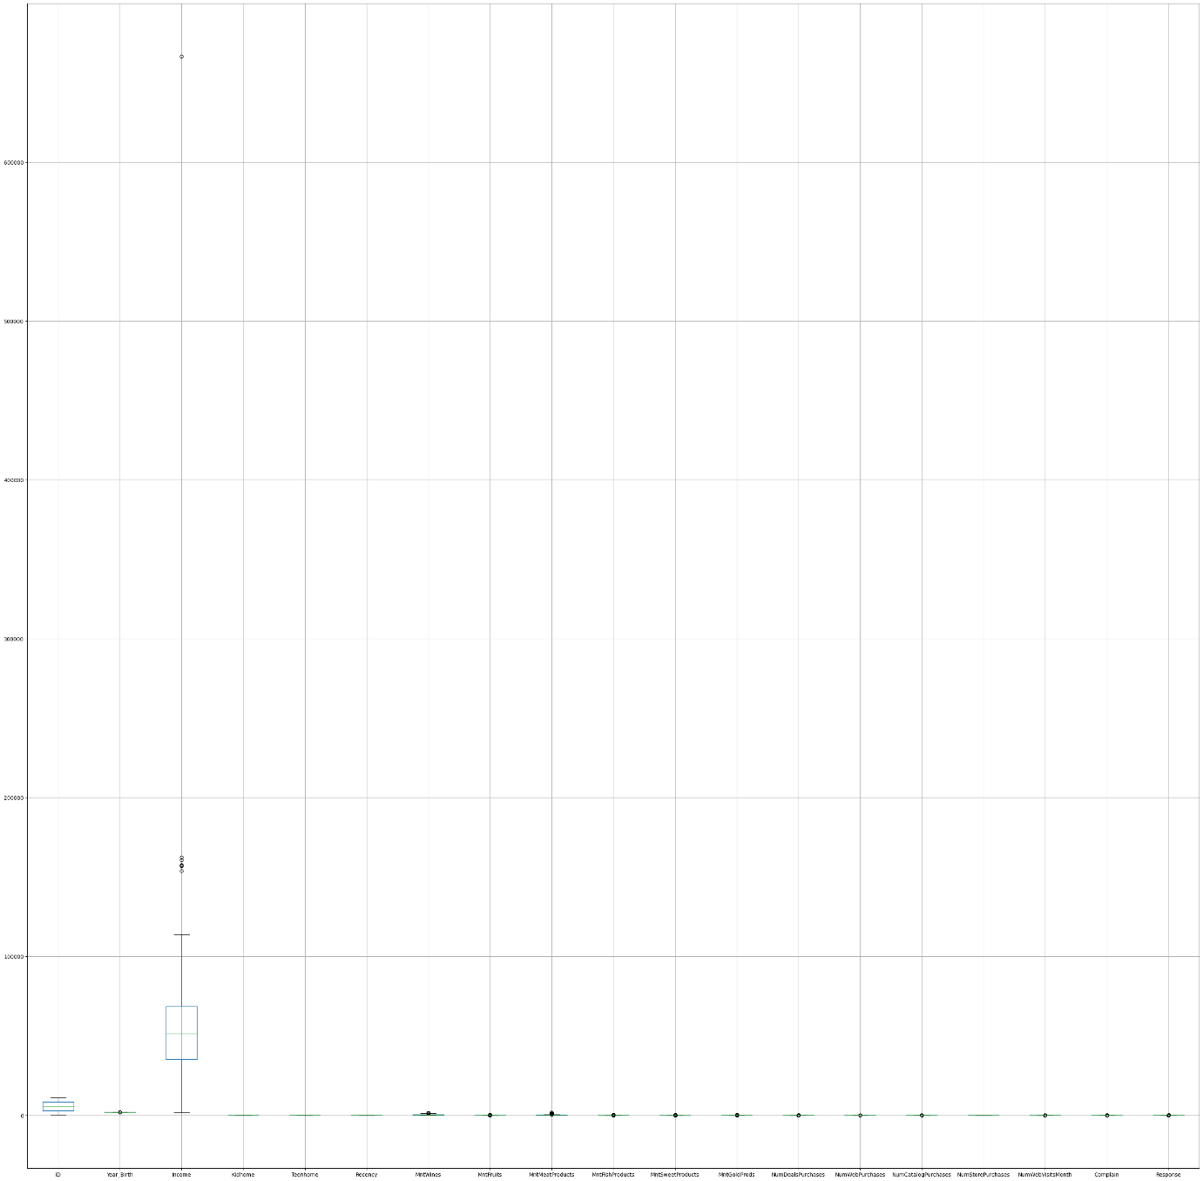

**Income Distribution Histogram:**

The following histogram shows the distribution of the income column, which represents the income of each customer. The x-axis shows the range of incomes, and the y-axis shows the number of customers who fall into each range. The histogram helps us understand the spread of income among the customers, and whether there are any outliers or anomalies in the data.

The majority of the population has an income clustered around the lower end specially under 100k. The count of individuals in this range is higher than any other range, which is around 600 individuals. As the income increases beyond 100k, the number of individuals drop sharply and the count becomes negligible beyond 200k. There are few outliers with very high income, up to 600k but those are rare.

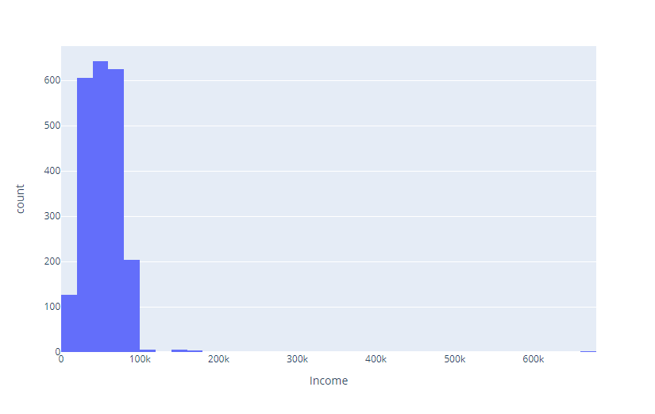

**Marital Status Distribution Histogram:**

This histogram shows the distribution of the customers based on their marital status, which is useful in understanding the different family structures. The x-axis represents the various marital statuses, and the y-axis shows the number of customers in each category. This help us in identifying the predominant marital statuses (married) among the customers. Around 500 individuals are single and approximately 600 are in relationship, but not married. The category of widow has the fewest individuals among the major statuses and rest all are negligible.

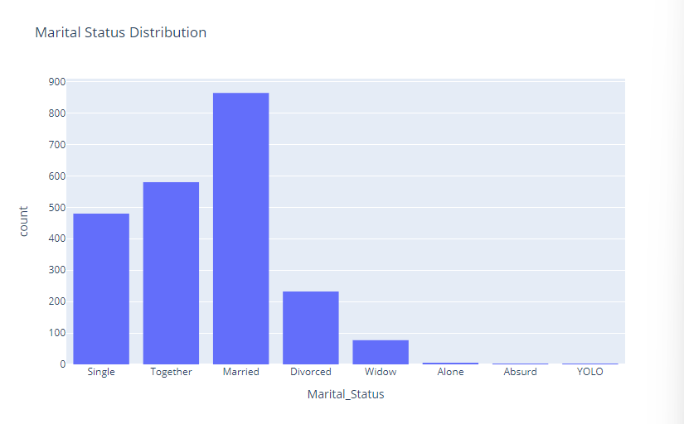

**Education Level Distribution Histogram:**

The following plot shows the distribution of customers based on their education level. The x-axis represents the different levels of education, and the y-axis shows the number of customers in each category. This provides us insights into the educational background of the customer base and help tailor marketing strategies accordingly. According to the graph, there are high number of graduates.

According to the bar chart, the most common education level is the graduation with over 1000 individuals in this category. The next group is with around 450 individuals for PhD. About 350 individuals have a Mater’s degree. The basic category has the fewest people and around 150 fall under 2nd cycle.

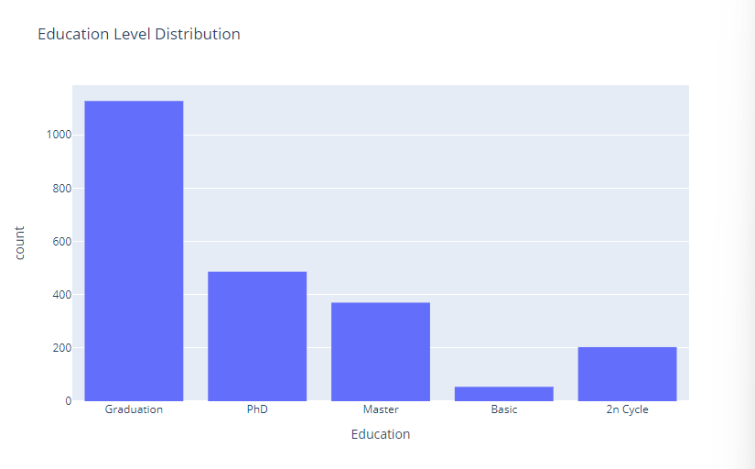

**Correlation Heatmap Interpretation:**

The heatmap shows the correlation between the different features in the dataset. The colour intensity indicates the strength of the correlation, with darker colours representing strong correlations (both positive and negative).

1. Strong Positive Correlations: MntWines, MntMeatProducts, MntFruits, and MntFishProducts show strong positive correlations with each other, indicating that customers who spend more on one category tend to spend more on others as well.

NumCatalogPurchases and NumDealsPurchases also have a strong positive correlation, suggesting that customers who frequently purchase via catalog also take advantage of deals.

1. Strong Negative Correlations: Recency shows a strong negative correlation with NumWebVisitsMonth, NumStorePurchases, and NumCatalogPurchases implying that customers who have made recent purchases tend to visit the website and stores less frequently.

Income is negatively correlated with recency, indicating that higher income customers tend to make purchases more recently.

1. Income has a moderate positive correlation with MntWines, MntMeatProducts, MntFruits, and MntFishProducts showing that higher-income customers tend to spend more on these products.

Response (the target variable) shows a moderate positive correlation with NumWebPurchases, NumCatalogPurchases, and MntWines showing that customers who engage more with online and catalog purchases spend more on wines are more likely to respond positively to campaigns.

1. Other Correlations: NumWebVisitsMonth has a positive correlation with NumWebPurchases showing that customers who visit the website more frequently also make more purchases online. Kidhome and Teenhome have a low correlation with most spending variables, indicating that the presence of children or teenagers in the household does not significantly affect spending patterns.

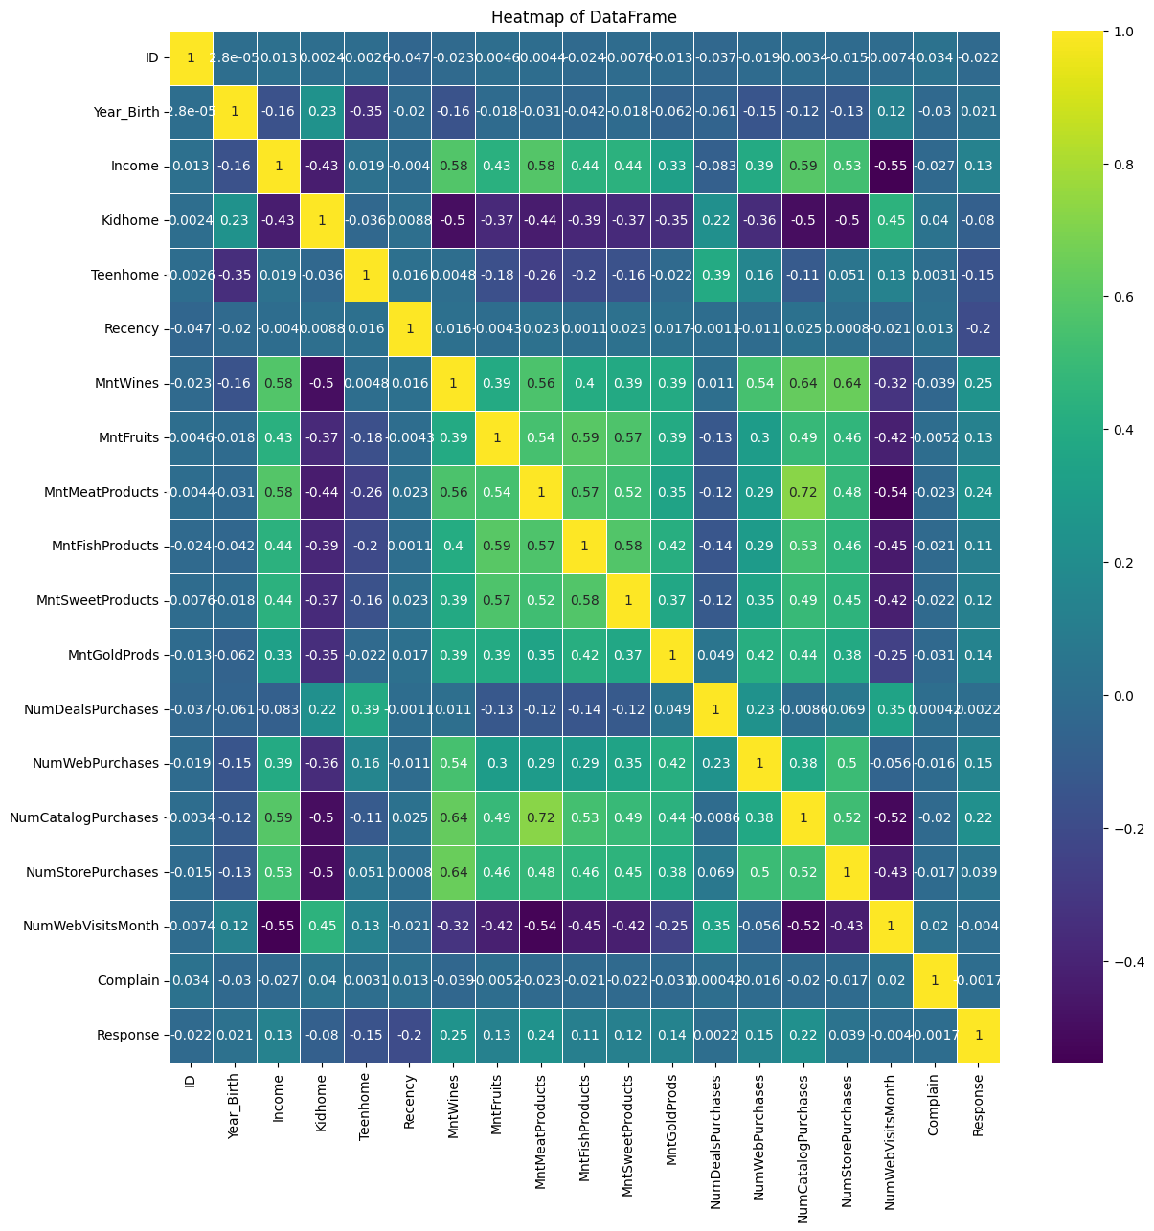

Following is the representation of variables that have been included in this study:

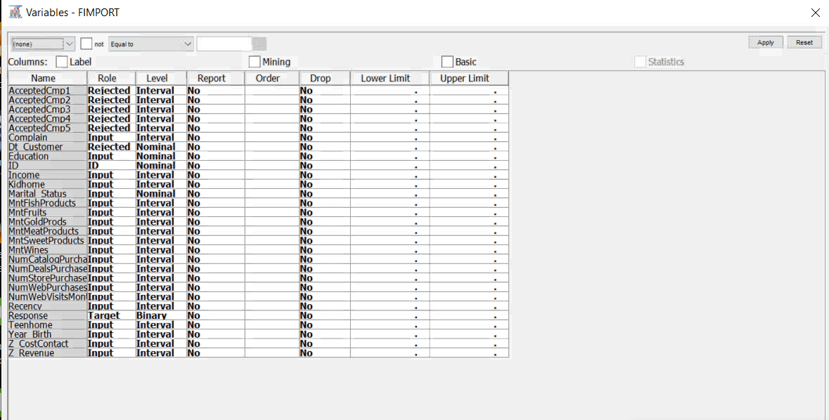

We rejected the campaign response as we are not considering previous campaign data for our data exploration. Here, ‘Response’ will be the variable which is Target. Response is the target and the level is made binary for the same. Binary variables are categorical variables that can take only one of two values. A brief range of product lists, income, education, and marital status is kept as input and the level is interval. For interval, objects are attributed with the value of numbers which reflects the difference of attributes.

# Filter Node

The filter node in SAS Enterprise Miner will help us apply a filter on the values of the variables. In this study, we have applied a filter on the variable amt_wines to filter out people who have spent more than or equal to $1000 on wines in 2 years. We have used this filter node because this variable was highly skewed, therefore we eliminated the outliers.

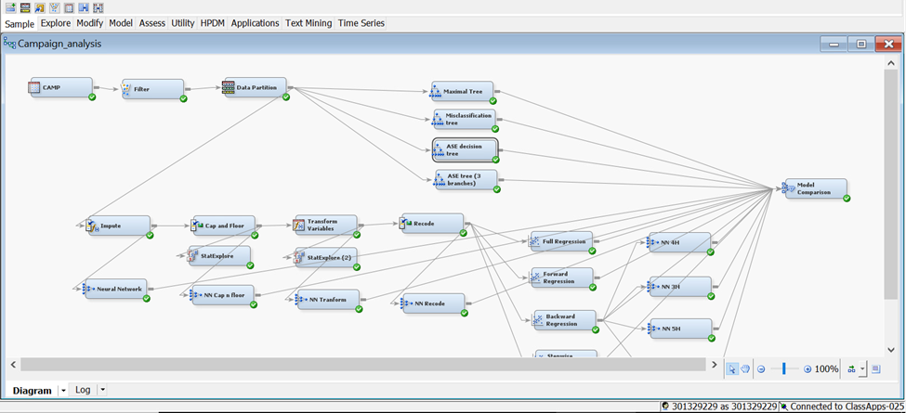

# Data Partition

The data Partition node in SAS Enterprise Miner will help users split data before modeling. The data Partition node splits the dataset into Training, Validation, and Test datasets. Here, Training data is used for preliminary model fitting whereas validation data is used for running and monitoring free model parameter estimates. Data partition helps significantly reduce the computation time for preliminary model running. Here, in this study, we made a partition of 60:40 (Train: Validation) in our data.

# Decision Tree:

A decision tree is a non-parametric supervised learning algorithm that is used for both regression and classification tasks.

It is a flowchart-like structure in which each internal node represents a decision based on the value of a particular feature, each branch represents the outcome of that decision, and each leaf node represents the final outcome.

Below are the terminologies used in the Decision Tree:

* **Root Node:** This is the topmost node in the tree, representing the initial decision or feature to be considered.
* **Internal Nodes:** These nodes represent decisions based on the values of features. They split the dataset into subsets based on the values of a particular feature.
* **Branches:** Each branch represents the outcome of a decision or a path to follow.
* **Leaves (Terminal Nodes):** These are the end nodes that represent the final outcome or the classification result.

The decision tree node is connected to the data partition node.



1) **ASE decision tree** – The first decision tree is connected with a Data Partition node and average square error is used as the model assessment method. The Average Square Error of 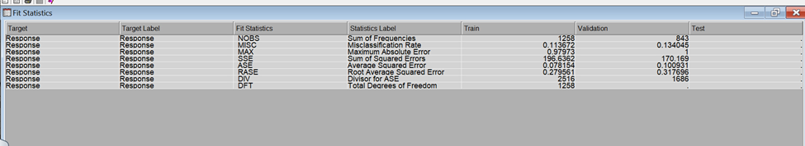

this tree is 0.100931.

2) **ASE Tree (3 branches)** - Next, another decision tree is connected with a Data Partition node where three-way splits are enabled by changing the maximum number of branches from a node to 3. The model assessment in this tree is ASE. The ASE value in this case is 0.101551.

3) **Misclassification tree**- The third decision tree made is the Misclassification tree whose Assessment measure has been changed to Misclassification. The average square error in this scenario is 0.108161.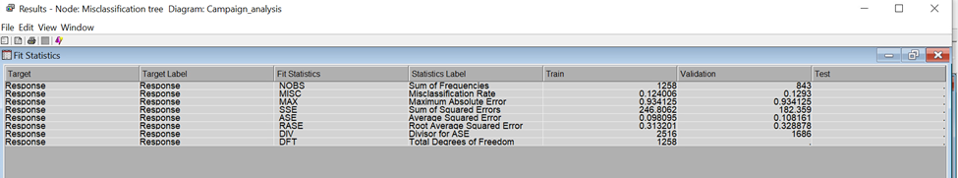

4) **Maximal tree**- The fourth decision tree that is connected now is a Maximal tree. The method from default has been changed to Largest. The average square error in the case of Maximal tree is 0.10591.

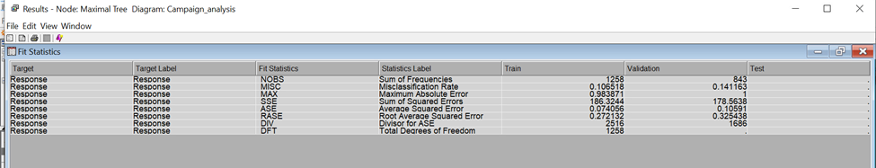

The Average Squared error is the mean of squared difference between a target and an estimate. This is a fundamental measure of model performance. The less the average square error, the better is the model.

As observed, the lowest average square error is in the first ASE tree with the value 0.100931.

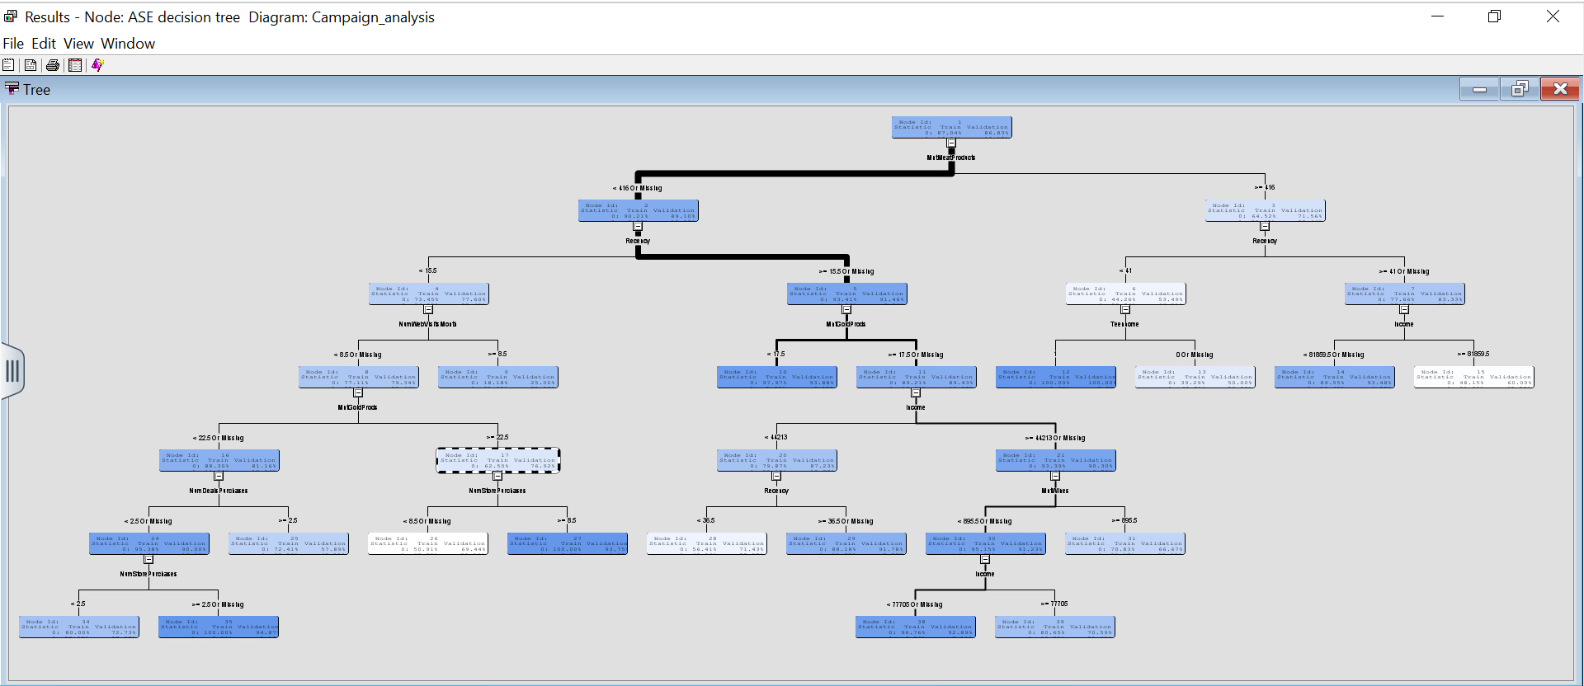

**Interpretation:**

For recency, it is evident that around 8.5% of customers have positively responded to the campaign; however, we could see a greater divide on the number of people who have not responded to the campaign.

The people whose income falls below $81,859.5 has a response rate of around 6.52% whereas, for those users whose average income is greater than or equal to $81,859.5, there is a greater chance of accepting the campaign by 40%.

Around 40% of the customers, who responded positively to the campaign, made a store visit of approximately less than 8 counts. Around 6.25% of the customers, who responded positively to the campaign, made a store visit of more than 8 counts.

75% of customers, who responded positively to the campaign visited the website more than 8 times. There is a high probability of cross-selling if the promotion is done through the website.

**Random Forest Model Results and corresponding interpretations**

We built a Random Forest model to classify data based on the provided features. The model was trained on 60% of the data and tested on the remaining 40%. Key evaluation metrics, including the confusion matrix, classification report, and accuracy score, were generated to assess the model's performance.

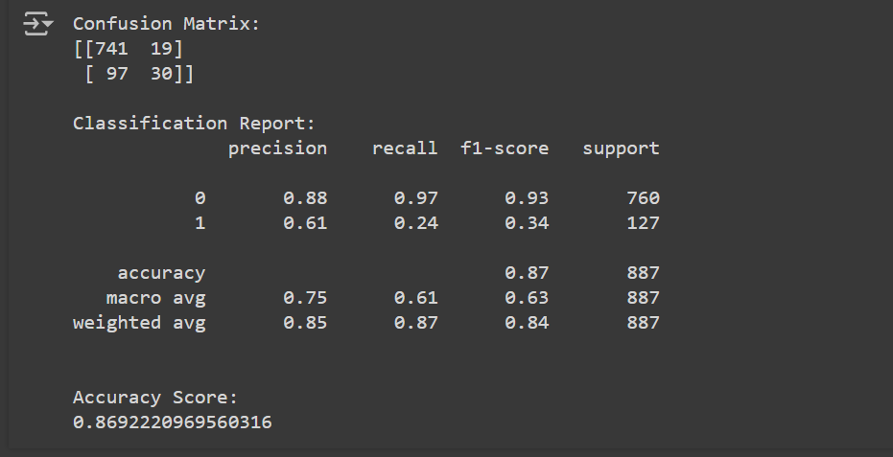

**True Negatives (TN):** 741 customers correctly identified as not responding to the campaign.

**False Positives (FP)**: 19 customers incorrectly identified as responding to the campaign.

**False Negatives (FN):** 97 customers who responded to the campaign but were not identified as such.

**True Positives (TP):** 30 customers correctly identified as responding to the campaign.

**Business Interpretation – Model Performance**

The model has an overall accuracy of 86.92%, indicating it correctly predicts the response to the campaign for the majority of the cases.

The model performs exceptionally well in identifying customers who do not respond to the campaign (Class 0) with a high recall of 97% and a precision of 88%. This means the model is very good at identifying non-responders and has a low rate of false positives.

However, the model struggles to accurately identify customers who do respond to the campaign (Class 1). The recall for responders is only 24%, meaning the model misses a significant number of actual responders. The precision is also relatively low at 61%, indicating that when the model predicts a response, it is correct only 61% of the time.

**Marketing Interpretation**

**Non-Responders:**

The model is highly effective at identifying customers who are unlikely to respond to the marketing campaign (Class 0). It correctly identifies 97% of these non-responders, with only a small number of false positives (19 out of 760).

**Responders:**

The model has a moderate precision (61%) but low recall (24%) for customers who are likely to respond to the campaign (Class 1). This means it correctly identifies only 24% of actual responders, missing 76% of them. However, when it does predict a response, it is correct 61% of the time.

**Boosted Tree Model Results and corresponding interpretations**

A Boosted Tree model using Gradient Boosting to classify data. The model was trained on 60% of the dataset and tested on the remaining 40%. The performance of the model was evaluated through the confusion matrix, classification report, and accuracy score, providing insights into the model's accuracy and predictive capabilities.

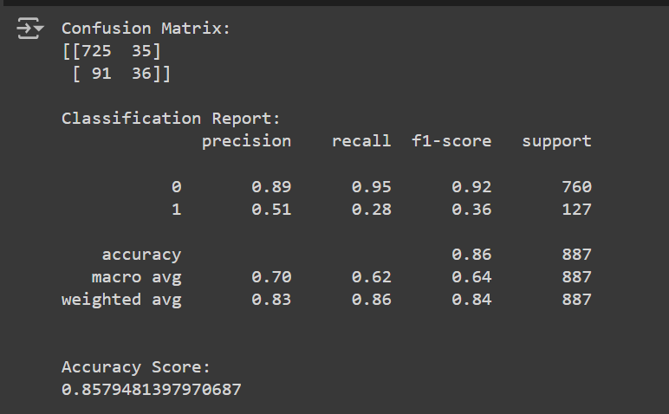

**True Negatives (TN):** 725 customers correctly identified as not responding to the campaign.

**False Positives (FP):** 35 customers incorrectly identified as responding to the campaign.

**False Negatives (FN):** 91 customers who responded to the campaign but were not identified as such.

**True Positives (TP):** 36 customers correctly identified as responding to the campaign.

**Business Interpretation – Model Performance**

The model is highly accurate (85.79%) overall and performs well in identifying non-responders (Class 0) with high precision (0.89) and recall (0.95). This means the model is effective in predicting customers who are unlikely to respond to the campaign.

The model has moderate precision (0.51) but low recall (0.28) for predicting responders (Class 1). This means it correctly identifies only 28% of the actual responders and misses 72% of them, indicating room for improvement.

**Marketing Interpretation**

**Non-Responders:**

The model correctly identifies 95% of non-responders, with a precision of 89%. This means that the model is highly reliable in predicting customers who will not respond to the marketing campaign.

**Responders:**

The model has a lower recall (28%) for responders, meaning it correctly identifies only 28% of actual responders. The precision is 51%, indicating that when the model predicts a responder, it is correct about half the time.

# Regressions

Now in this step, we have tried to build up the best possible regression model for our data to know the consumer’s behavior towards a new campaign and various variables affecting that.

We will be undergoing different steps to make our data best-fit for the analysis and four different types of regression models will be implemented to find out the best possible model.

**Imputation node:** As we know regression models tend to ignore the data with missing values therefore, we need to deal with missing values in our data. Here an impute node is connected to do so. In our case, this impute node replaces all the missing values with the mean value.

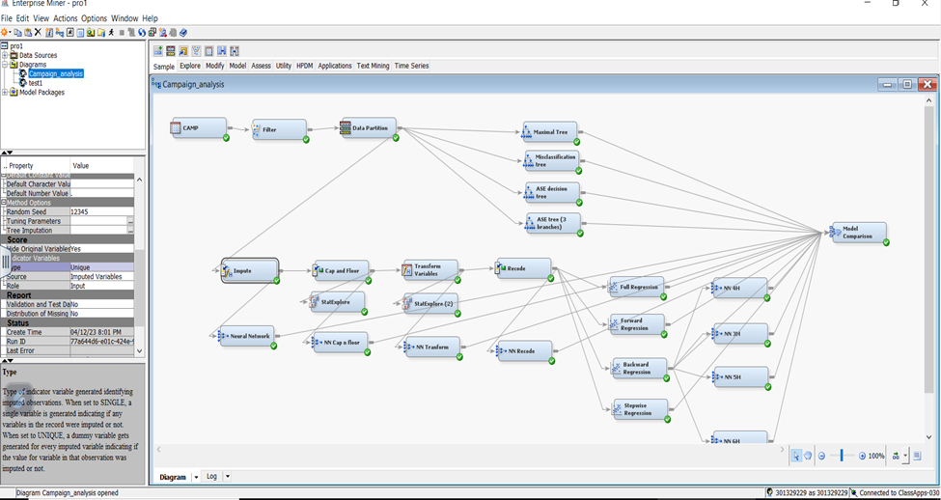

Below is the output for our impute node as we can observe the variable Income had 13 missing values which have been replaced now with the mean value of **50661.47.** Also, according to our settings, a unique indicator variable is assigned to our imputed variable.

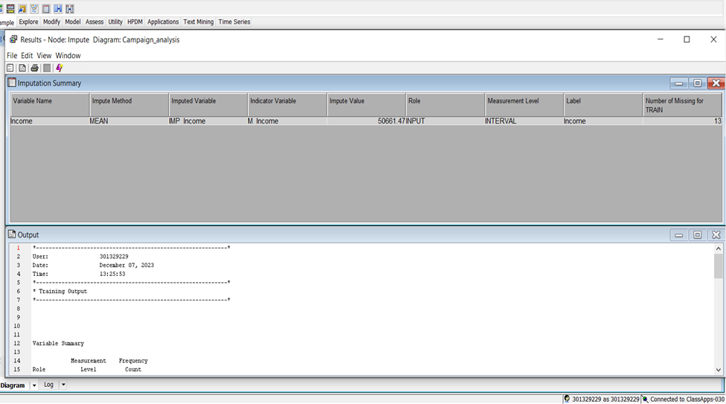

**Cap and Floor (Replacement Node):**

The Cap and Floor Replacement Node in SAS allows users to set upper (cap) and lower (floor) limits on data values, ensuring that values exceeding or falling below these thresholds are replaced or modified. The Cap and Floor Replacement Node provides a flexible means to enhance data quality, ensuring that extreme values are managed effectively for more reliable and accurate analyses in various fields.

Here in our case, the values are limited and computed based on 3 standard deviations; the values that are above or less than 3 standard deviations are replaced.

Below is the result of our Cap and floor node that shows all the upper limit and lower limit values for our variables.

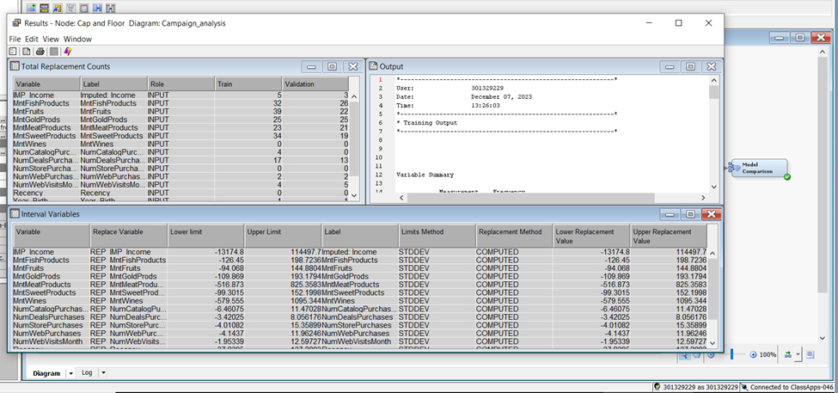

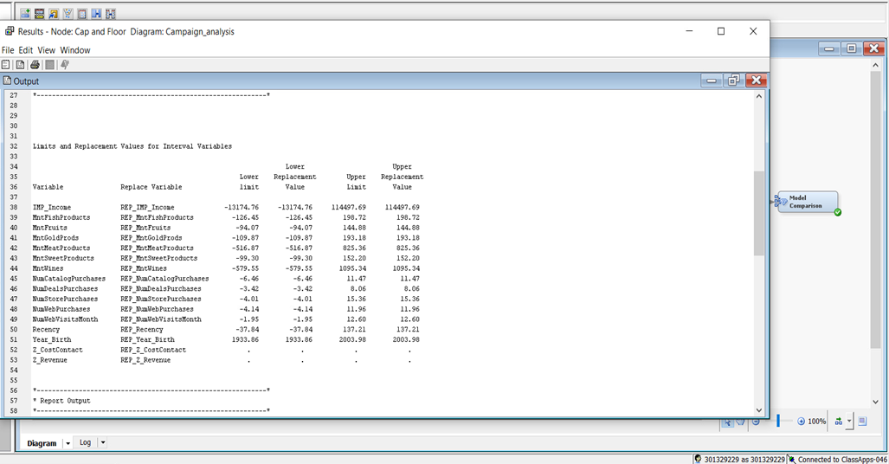

The table provided below shows the number of replaced values for both training and validation data.

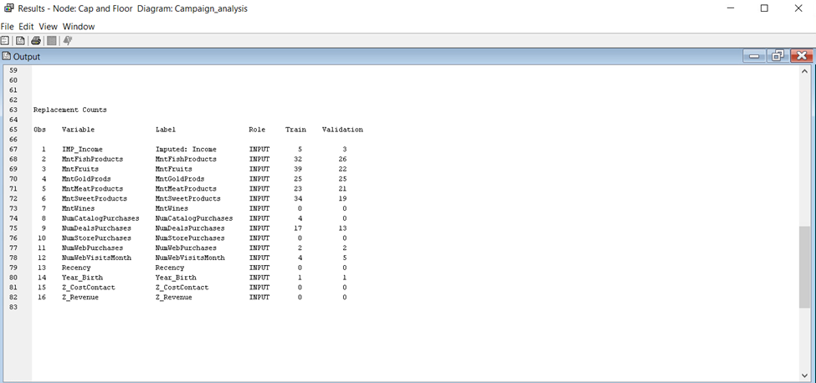

**Stat-Explore:** We attached a stat explore node to our Cap and Floor replacement node and that enabled us to explore our data and gave information regarding variables, their roles, and the skewness of different variables.

In the output provided below it can be observed that many of our variables are skewed hence our next step will be to fix the skewness of these variables.

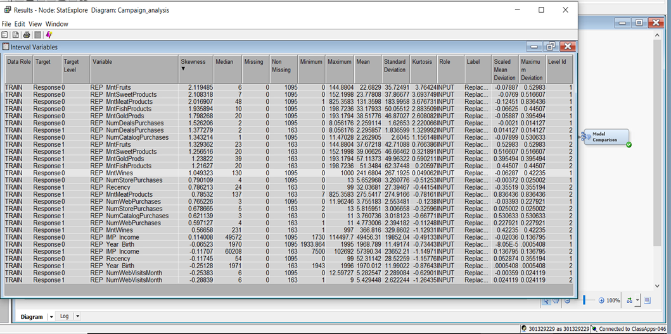

# Transform Variables Node

The transformation of variables is done to make sure that the data is not vulnerable to extreme values. As we observed from the stat explore node the variables: **MntFruits, MntSweetProducts, MntMeatProducts, MntFishProducts, MntGoldprods, NumDealsPurchases, NumCatalogsPurchases, and MntWines** are skewed. To remove the skewness these variables are transformed using log transformations. In the Variable MntGoldProducts, the log transformations were not effective enough to reduce the skewness, therefore the ‘best’ method is applied to it.

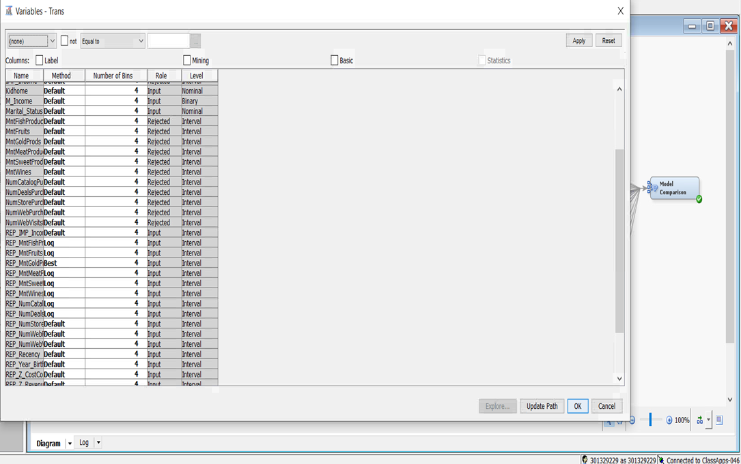

The table given below is the result of stat explore node 2 which is connected to the transformation node of our model. This table depicts that the transformation of variables was effective in eliminating the skewness of our Variables. As we can observe all the variables have skewness below the threshold i.e. 1.

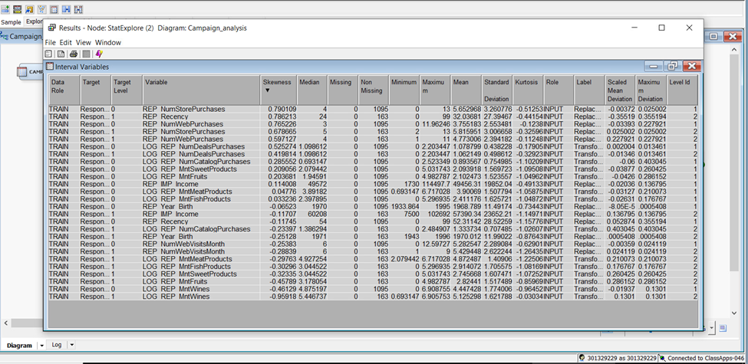

# Recode (Replacement Node)

The recode replacement node is connected to the transform variables node to reduce the number of levels in categorical variables. As we know, the inclusion of a categorical input with excessive levels can lead to overfitting.

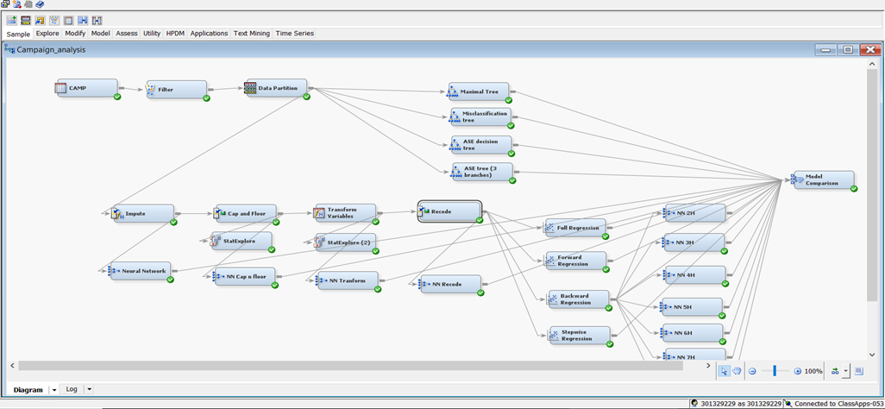

The newly added replacement node will recode the categorical variables hence for the interval variables the default limits method is set to none.

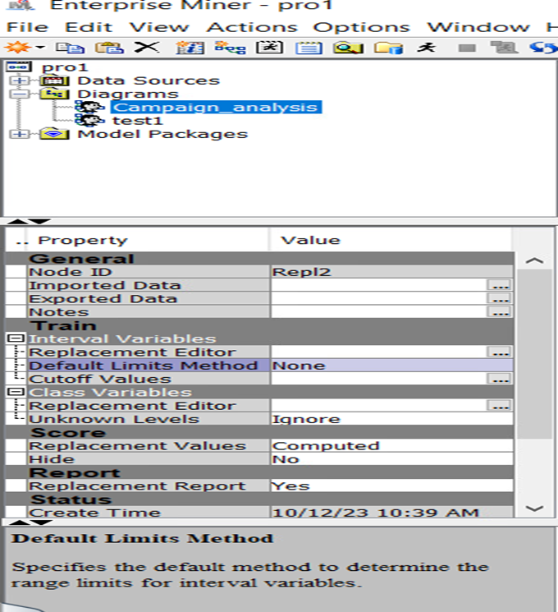

In the screenshot of the replacement editor given below it can be observed that for our model we have recoded the categorical variables Education and Marital_status.

The levels of Education are consolidated as follows:

* Levels Graduation and 2n_cycle indicate education below post-graduation and are grouped into a single level, G2N.
* Levels Masters and Ph.D. indicate education after graduation and are grouped into a single level, PM.
* Level Basic indicates education level below graduation and is placed into a single level B.

Similarly, for marital Status, the levels are consolidated as follows:

* Levels Married and Together indicate more than 1 person living and are therefore grouped into a single level, MT.
* Levels Single, Divorced, and Widow indicate 1 person living and are therefore grouped into a single level, SDW.

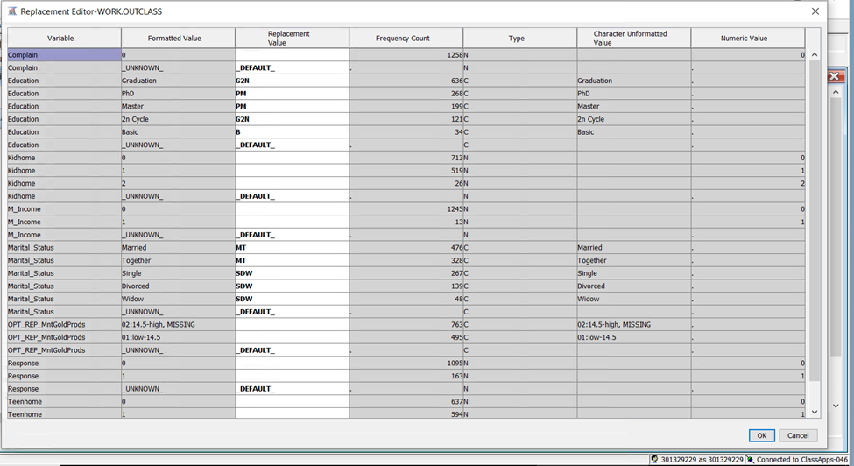

**NOTE:** We ran our model initially without the recode node and got the lowest ASE of 0.099597 (**Backward regression)**, later on by adding the recode node the validation ASE dropped (0.096945) significantly hence we decided to keep it in our model.

# Regression Nodes:

In our model, we started with a full regression model, and then to select the best inputs and mitigate possible overfits we ran different sequential selection methods(Forward, Backward, and stepwise) in order to select the best logistic regression model for our data. The Validation Average Squared Error is used as a measure to select the best Regression model.

Below are the outputs and settings of the different models that we ran:

**FULL REGRESSION (Validation ASE: 0.097834)**

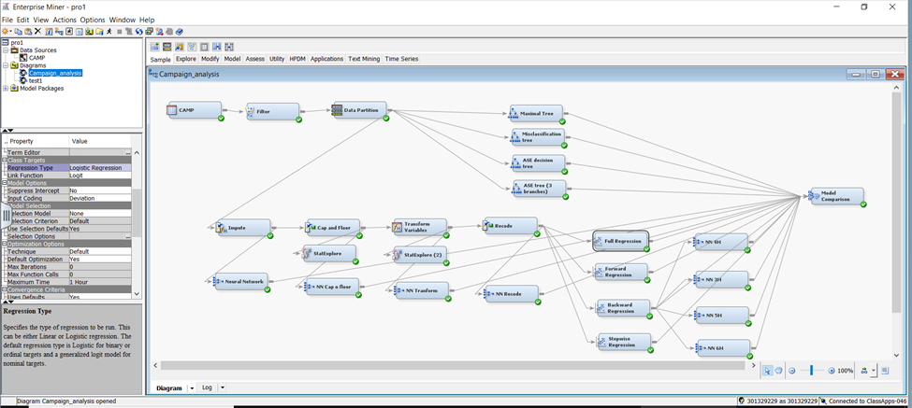

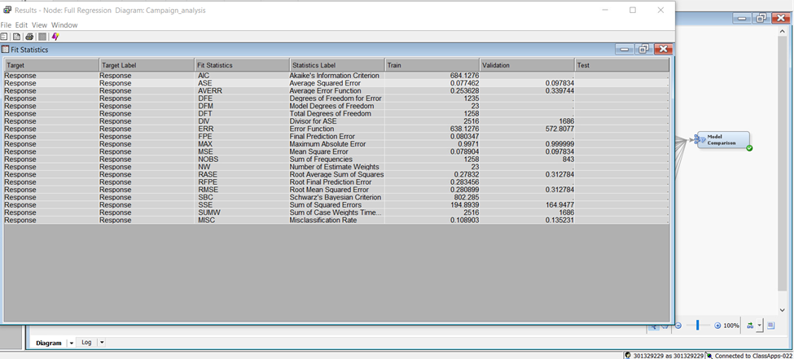

**FORWARD REGRESSION (Validation ASE:0.099817)**

**\*\*For all the sequential selection models the validation error is taken as the selection criteria.\*\***

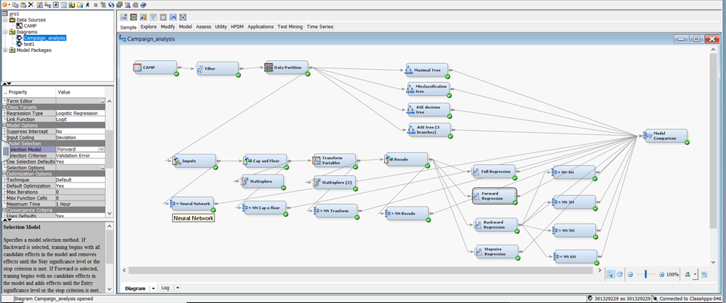

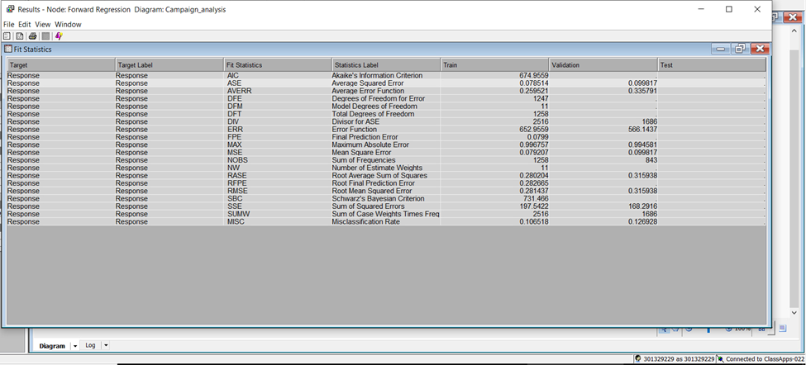

**BACKWARD REGRESSION ( Validation ASE: 0.096945)**

Backward selection creates a sequence of models of decreasing complexity. This is the model that has the lowest Validation ASE; hence, our best regression model.

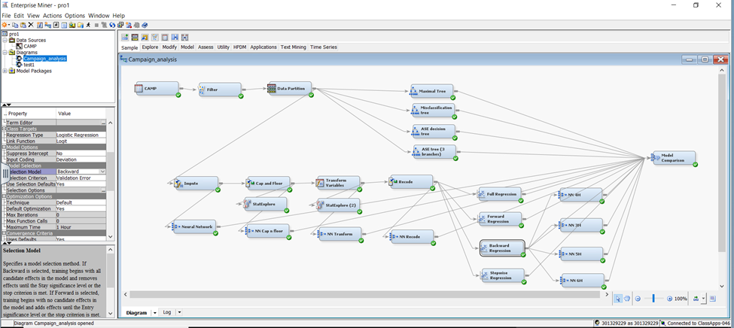

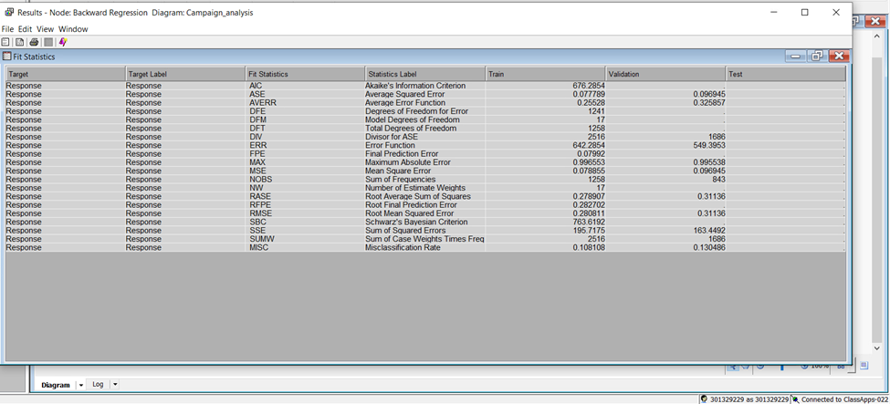

Now, we will analyse the output of this model in detail.

The odds ratio Estimates for this model are given below along with their interpretation:

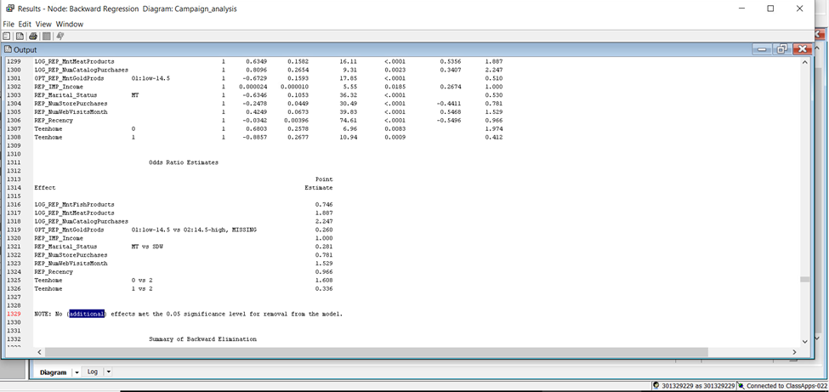

**The odd ratios can be estimated as follows:**

* The likelihood of accepting the campaign reduces by 25.4% whenever the amount spent on fish products increases by the multiple of 2.72.
* The likelihood of accepting the campaign increases by 88.7% whenever the amount of meat products increases by the multiple of 2.72.
* The likelihood of accepting the campaign increases by 124.7% whenever the number of catalogue purchases increases by the multiple of 2.72.
* The customers spending less than 14.5 on gold products are 74% less likely to accept the campaign.
* Here, according to the odds ratio, the point estimate for income is 1.000. This signifies that the effect on campaign acceptance due to the change in income cannot be captured by these significant figures. We might need to increase the number of significant digits for our result.
* The people who are married or live together are 71.9% less likely to accept the campaign.
* With every one-unit increase in the number of store purchases, the likelihood of accepting the campaign decreases by 21.9%.
* With every one-unit increase in the number of web visits per month, the likelihood of accepting the campaign increases by 52.9%.
* With every one-unit increase in recency, the likelihood of accepting the campaign decreases by 3.4%.
* The families with zero teenagers at home are 60.8% more likely to accept the campaign as compared to the families with two teenagers.
* The families with one teenager at home are 66.4% less likely to accept the campaign than those with two teenagers.

# Variable importance

The output provided below highlights the importance of different variables in the model. The variable with the highest chi-square value is the most important. **(Recency)**

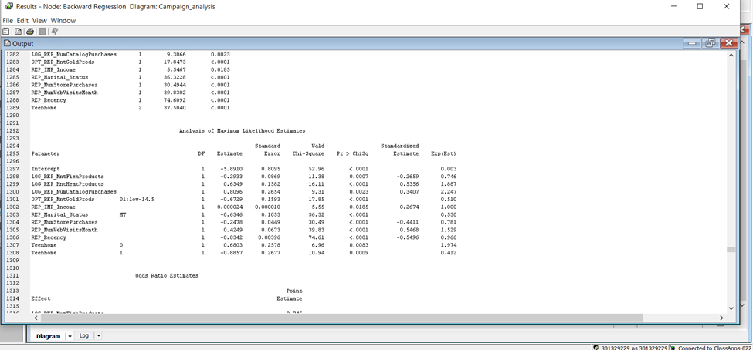

**STEPWISE REGRESSION (Validation ASE:0.099817)**

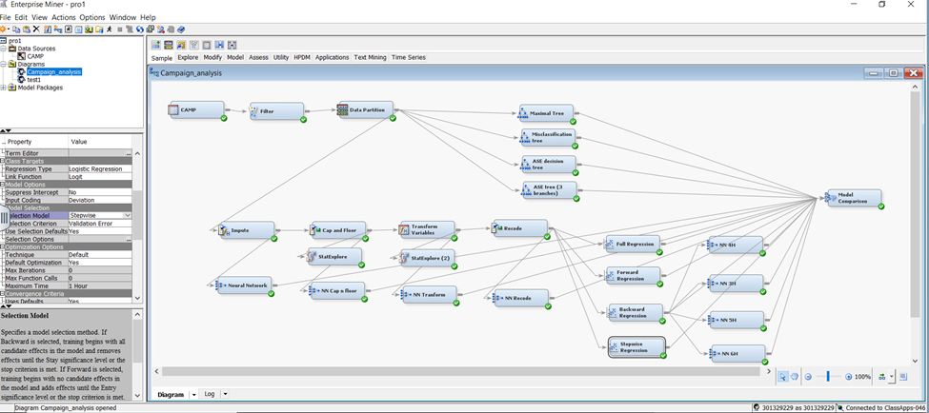

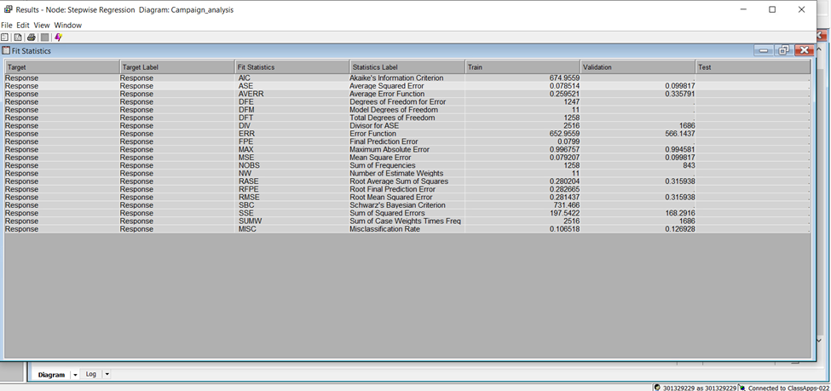

**Insights:**

Throughout this section, we have worked to create the best possible logistic regression model. To do so, we imputed the missing values, replaced the outliers, transformed the skewed values, recoded the categorical variables, and then ran various regression models. The backward selection model is the best logistic regression model for our data. It had the lowest Validation ASE of **0.096945.**

There are many variables included in this model and their relationship with our target (Response) is depicted using Odds Ratio Estimates. It is discovered that recency is the most important variable in the model based on its highest value of Chi-square.

In summary, campaign acceptance is influenced by various factors. Higher spending on fish products and catalogue purchases, more web visits, and a lack of teenagers at home are associated with increased likelihood. Conversely, increased store purchases, being married, higher recency, and having one teenager at home are linked to reduced acceptance. The impact of income on campaign acceptance remains inconclusive with a point estimate of 1.000, requiring more precise measurement.

# NEURAL NETWORKS

In this step, we have built a Neural Network model for our data to know the consumer’s behaviour towards a new campaign and various variables affecting that. In this model we have used different methods such as Imputation, Data Transformation, Recode, Cap & Floor and hidden units to tweak the model with best possible solutions.

We run our model from 2 Hidden units to 8 Hidden units. Hidden units are the neurons and nodes in the layers of Neural Network models which are not directly connected to the input and output variables. These hidden units play a crucial role in learning complex relationships and patterns from the input data.

In preparation for a neural network model, handling missing values is very crucial because missing values can lead to incomplete information, which will further impact the model's ability to learn and make accurate predictions.

So, we attached our Neural Network node (NN Impute) with an Imputation node in our model which helps maintain the integrity of the dataset by filling in missing values. Also , Imputation can lead to better model performance by providing a more complete dataset for training. Shown in screenshot below.

Further,In Neural Network data transformation is not required generally because the activation function of Neural Networks ultimately squash the extreme values by taking their hyperbolic tangents. The values get down in between -1 and 1 and hence, the values become smaller. However,we made a Neural Network model(NN Transform) with the data Transformation node to see what happens. Shown in below screenshot.

Also, we made a Neural Network node(NN Cap and Floor) and Neural Network recode(NN Recode) as shown in the below screenshot.

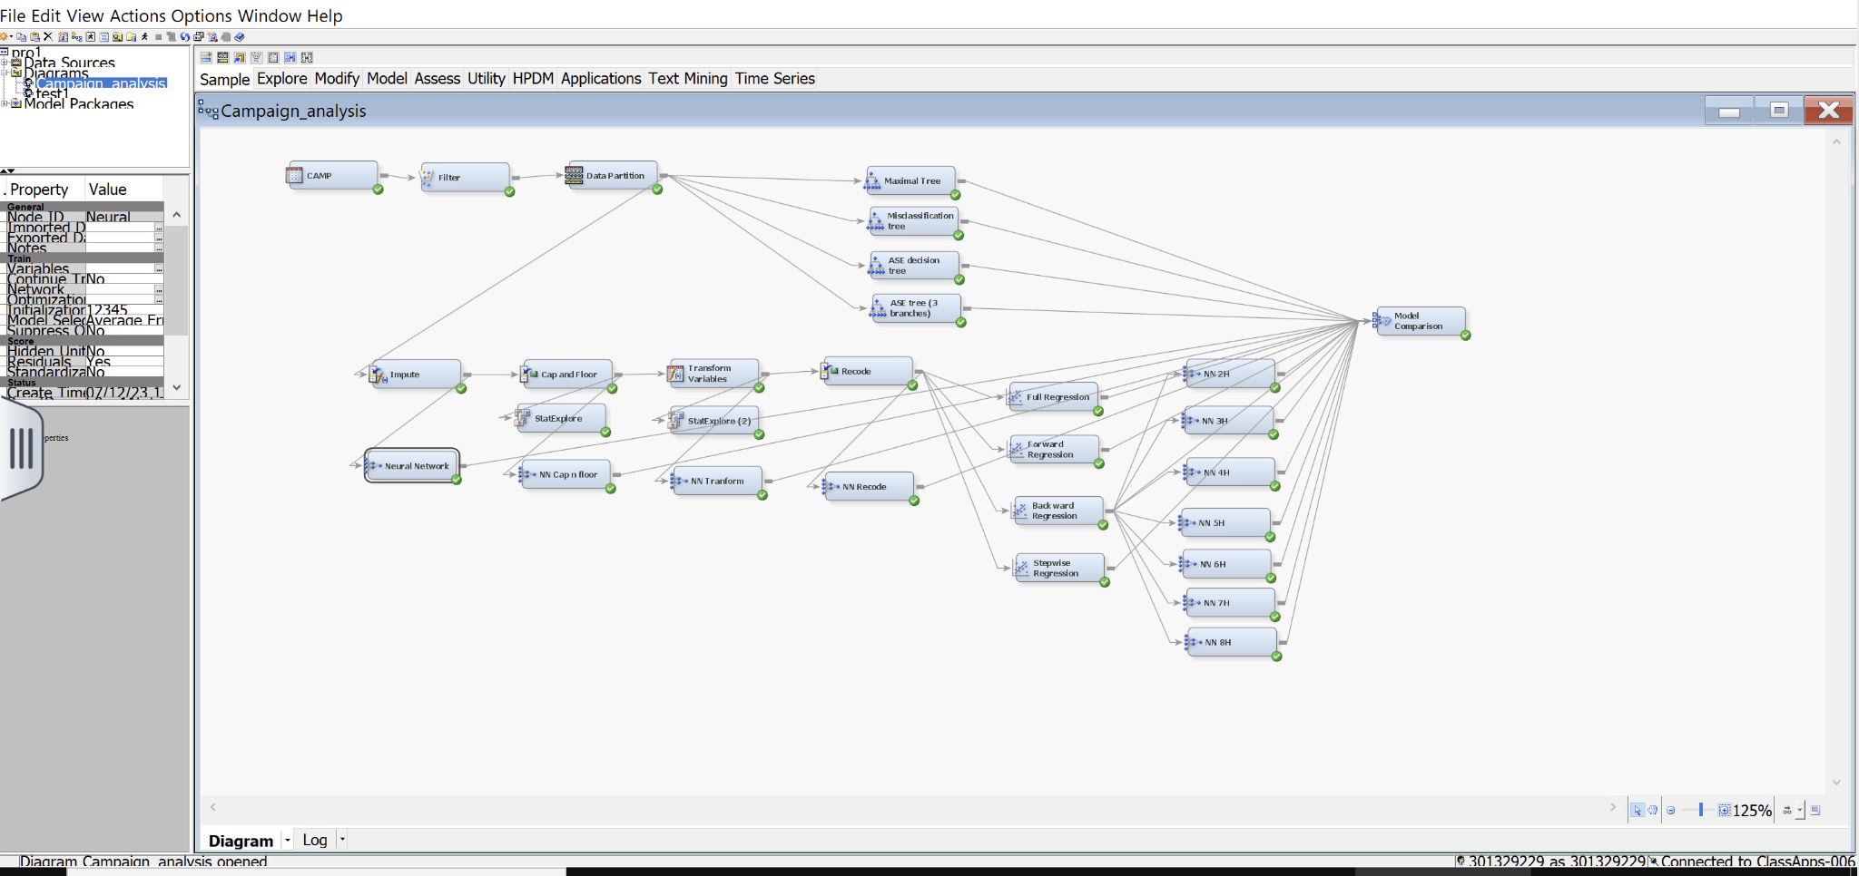

**RESULTS**

**Screenshot: 1 NN Impute**

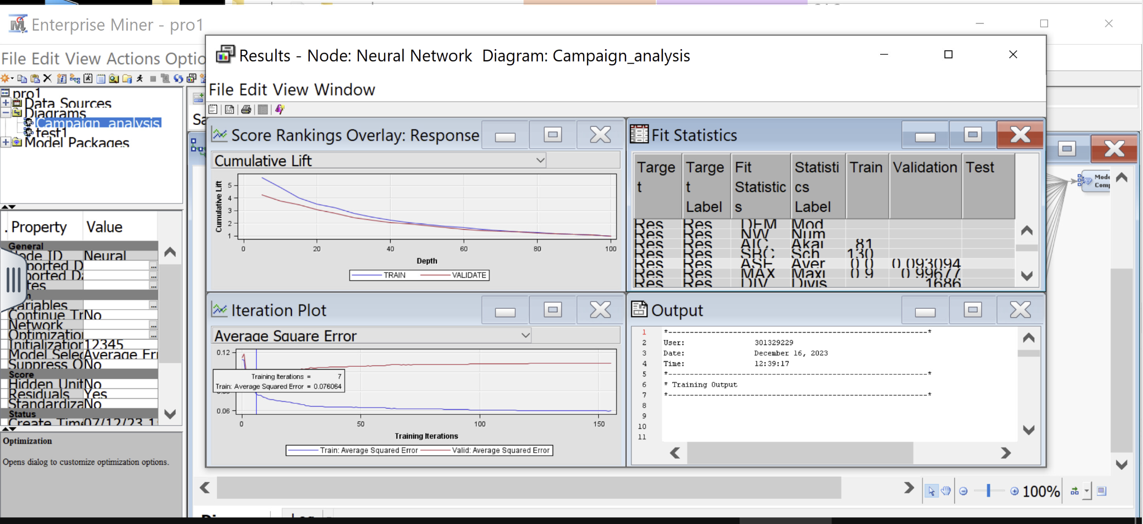

As we can see from the above screenshot the Average Square error for the validation is **0.093094** and we got this result at 7th Iteration. We ran this model for 200 Iterations but it converged at 155th Iteration. Convergence is a point when the model cannot further iterate.

**Screenshot: 2 NN Cap & Floor**

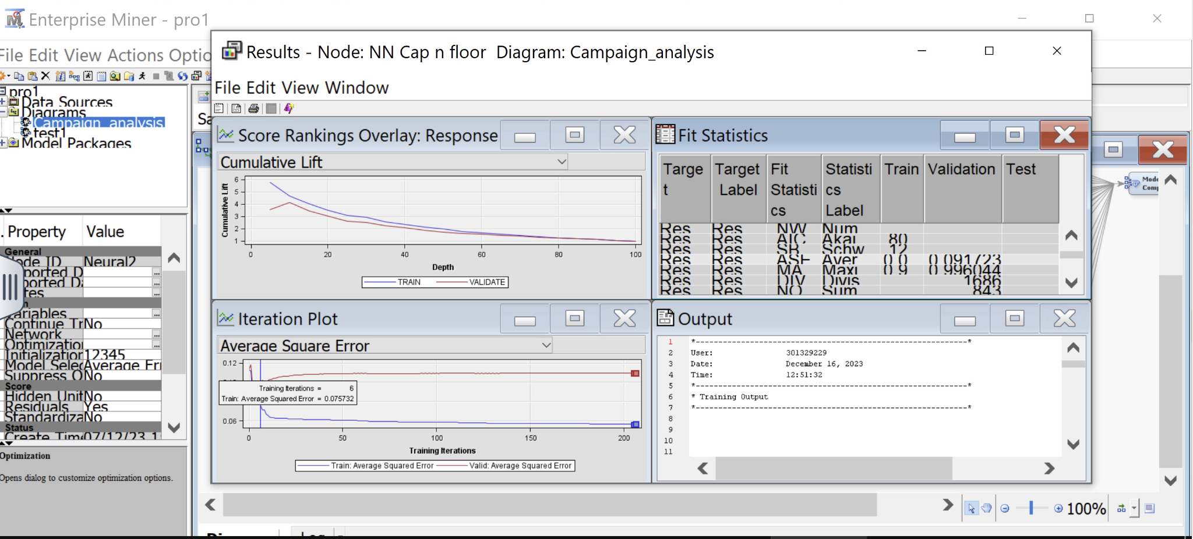

As we can see from the above screenshot the Average Square error for the validation further reduced to **0.091723** and we got this result at 6th Iteration. We ran this model for 200 Iterations but it did not converge then we ran it for 300 Iterations. It converged at 206th Iteration.

**Screenshot: 3 NN Transform**

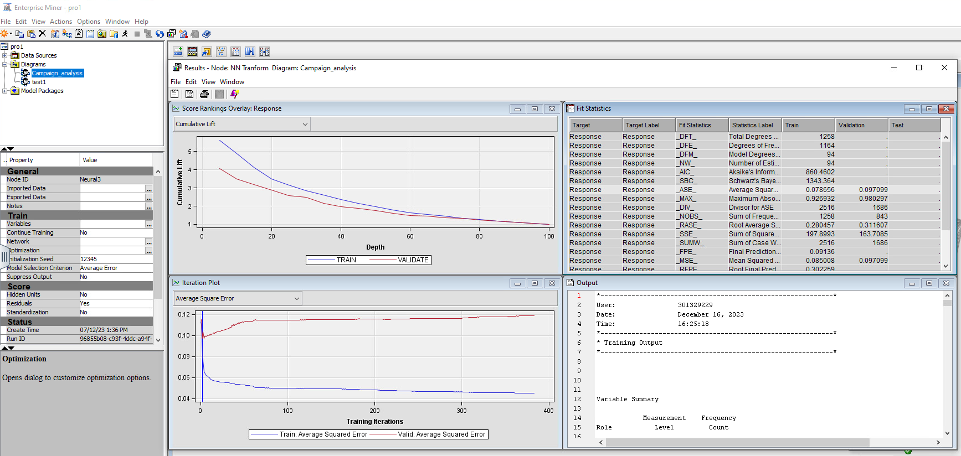

As we can see from the above screenshot the Average Square error for the validation increased to **0.097099** and we got this result at 3rd Iteration. We ran this model for 400 iterations because it was not converging until 350th iteration it converged at 383th iteration

**Screenshot: 4 NN Recode**

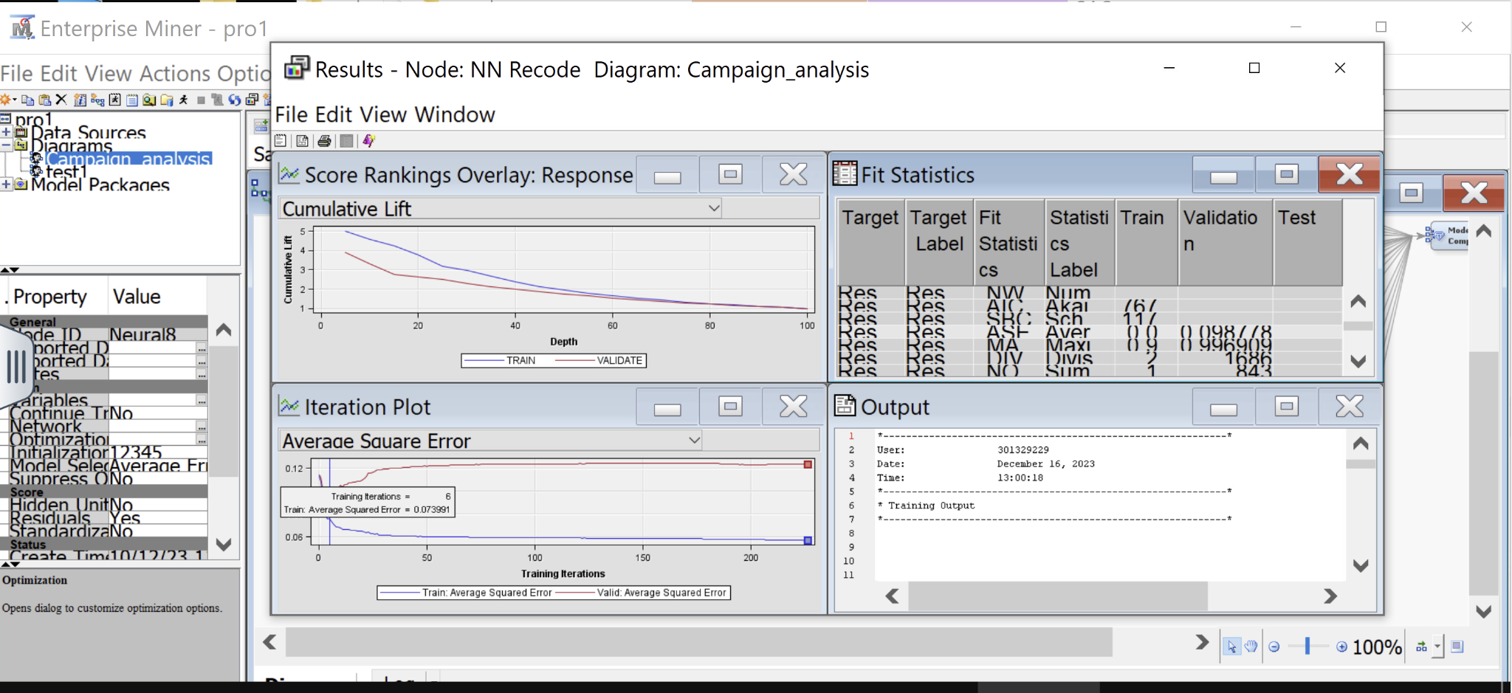

As we can see from the above screenshot the Average Square error for the validation further increased to **0.098778** and we got this result at 6th Iteration. We ran this model for 300 Iterations. It converged at 226th Iteration.

Now we made a Neural Network node and we connected that with our best regression model i.e. Backward regression to further optimise our model. We ran this model for 2 Hidden units to 8 Hidden units

**Screenshot: 5 NN 2Hidden units**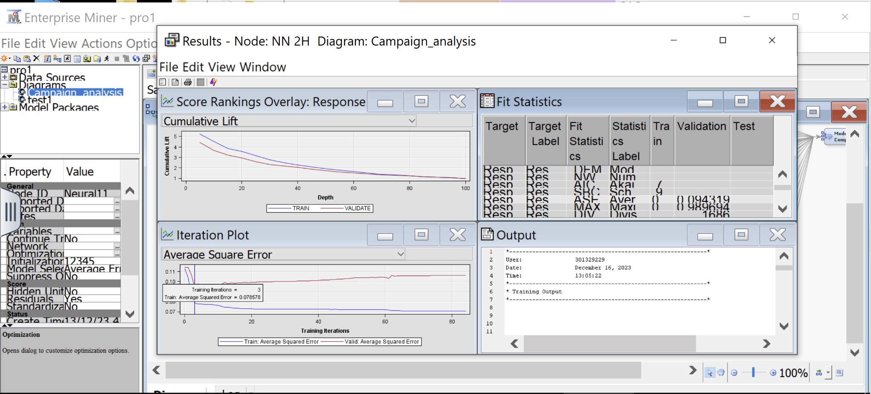

As we can see from the above screenshot the Average Square error for the validation further increased to **0.094319** and we got this result at 3rd Iteration. We ran this model for 300 Iterations. It converged at the 84th Iteration.

**Screenshot: 5 NN 3Hidden units**

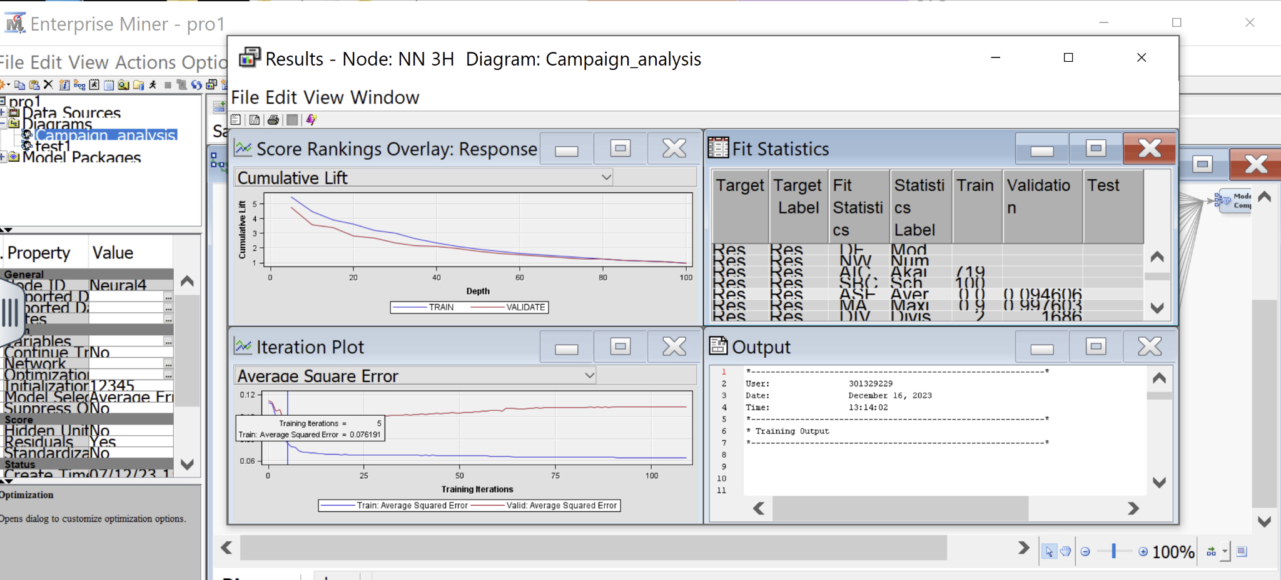

As we can see from the above screenshot the Average Square error for the validation further increased to **0.094606** and we got this result at the 6th Iteration. We ran this model for 300 Iterations. It converged at the 109th Iteration.

**Screenshot: 6 NN 4Hidden units**

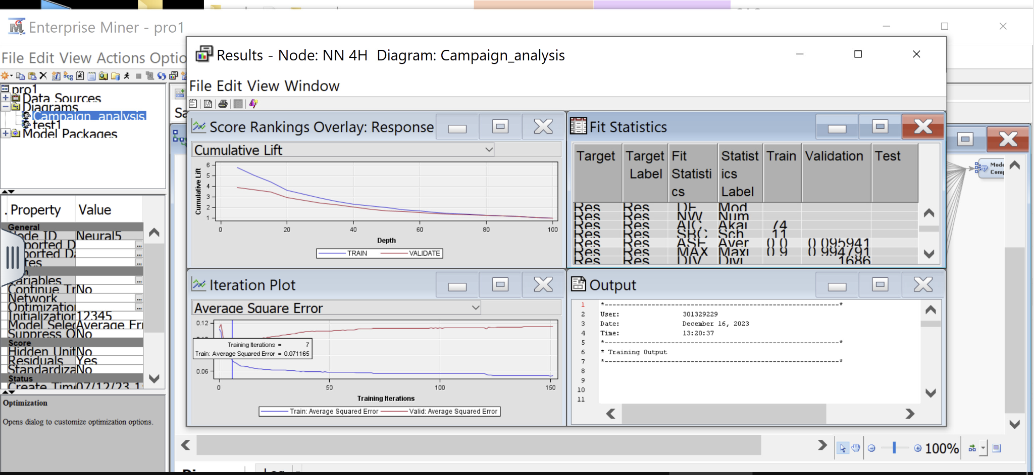

As we can see from the above screenshot the Average Square error for the validation further increased to **0.095941** and we got this result at 7th Iteration. We ran this model for 300 Iterations. It converged at the 151st Iteration.

**Screenshot: 7 NN 5Hidden units**

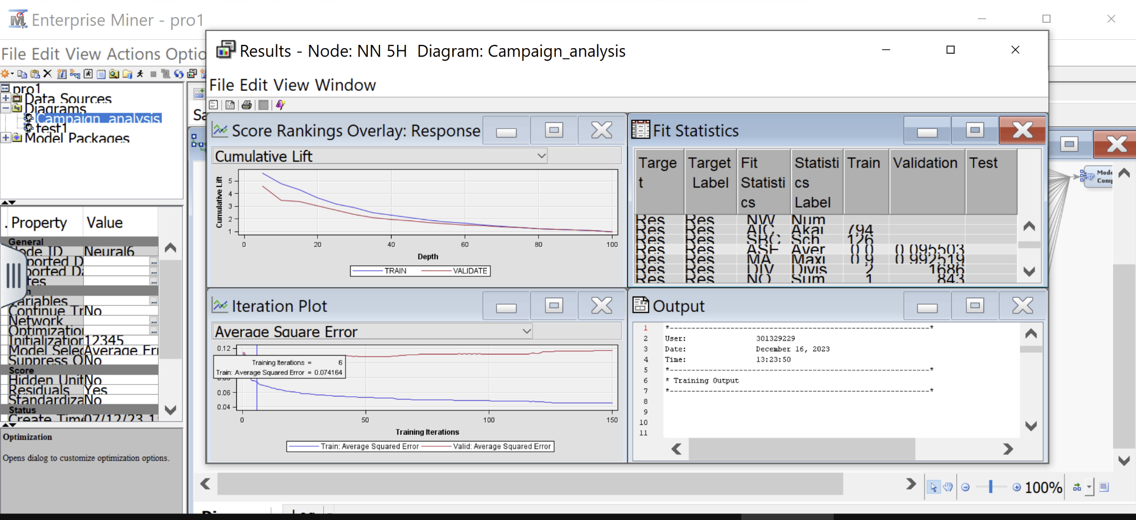

As we can see from the above screenshot the Average Square error for the validation decreased to **0.095503** and we got this result at 6th Iteration. We ran this model for 300 Iterations. It converged at the 150th Iteration.

**Screenshot: 8 NN 6Hidden units**

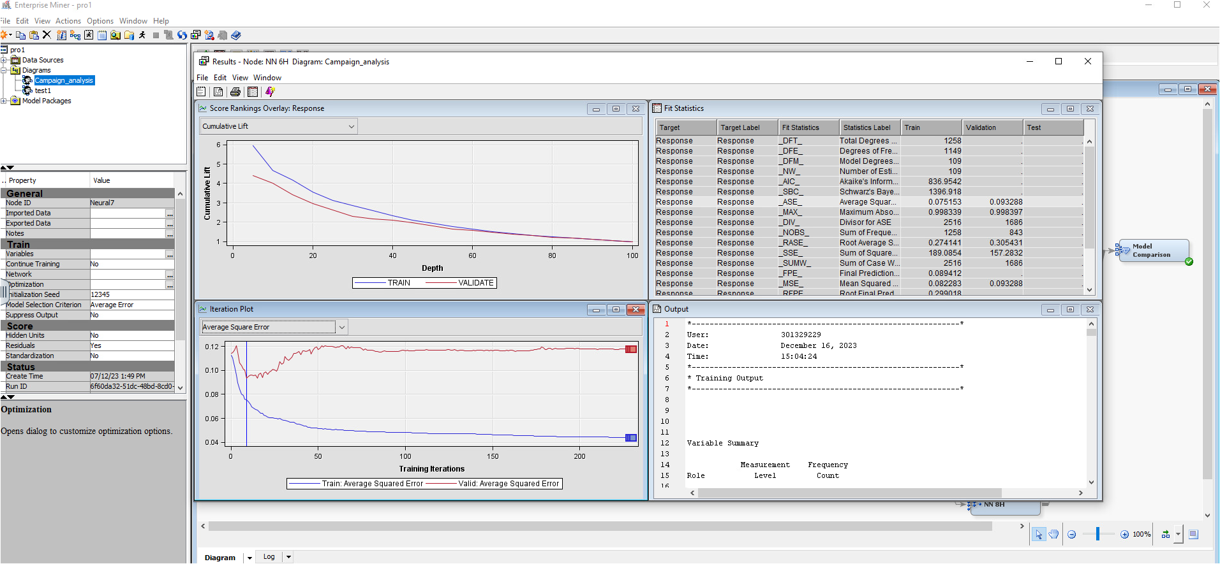

As we can see from the above screenshot the Average Square error for the validation decreased to **0.093288** and we got this result at the 10th Iteration. We ran this model for 300 Iterations. It converged at the 227th Iteration.

**Screenshot: 9 NN 7Hidden units**

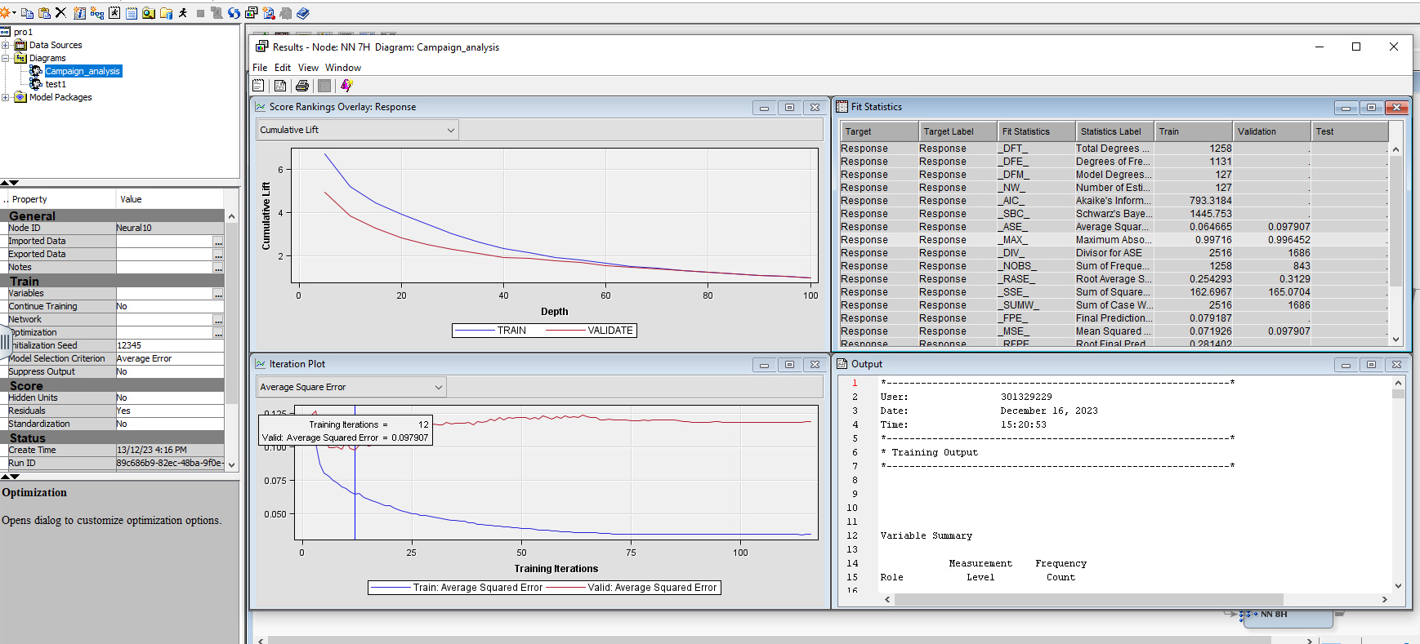

As we can see from the above screenshot the Average Square error for the validation increased to **0.097907** and we got this result at the 12th Iteration. We ran this model for 300 Iterations. It converged at the 116th Iteration.

**Screenshot: 10 NN 8Hidden units**

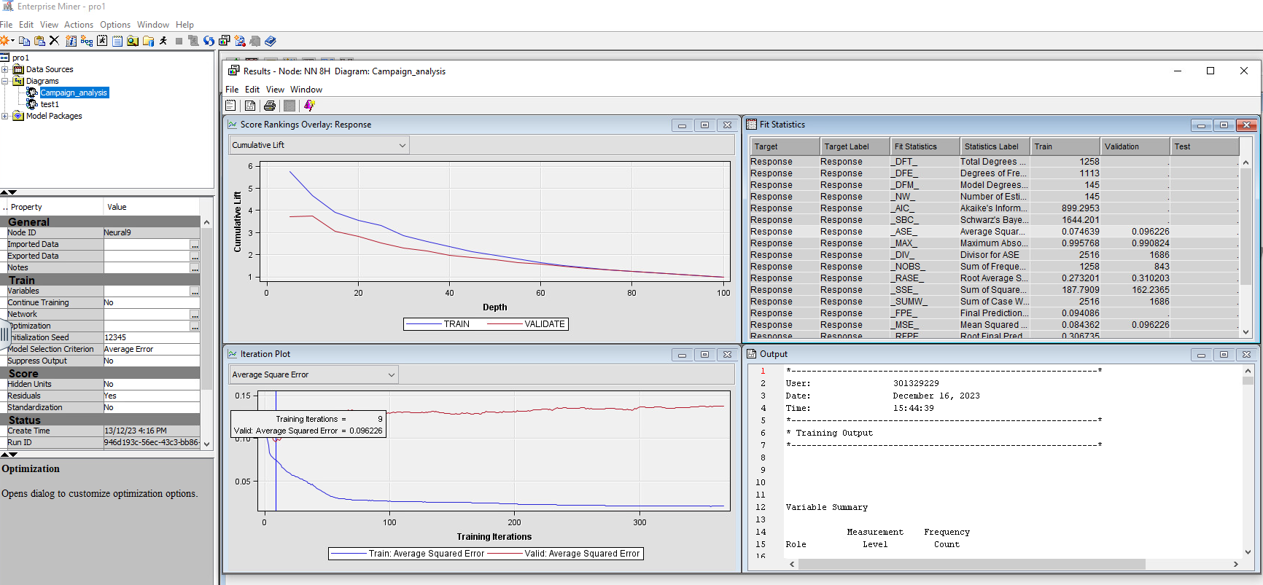

As we can see from the above screenshot the Average Square error for the validation decreased to **0.096226** and we got this result at 10th Iteration. We ran this model for 400 because it did not converge till 300 Iterations. It converged at the 367th Iteration.

# Comparison of Neural Networks with Hidden Units.

* We begin with the 2 hidden units and gradually increase their count to 8 hidden units and monitor the performance of all the neural networks.
* Until 5 Hidden Units the performance hits the plateau and it starts to degrade.
* At 6 Hidden units we got our best model for hidden units with validation average squared error 0.093288.
* After this model's performance starts to degrade again until the 8 Hidden unit.

**Comparison of all the Neural Networks.**

|  |  |  |  |  |
| --- | --- | --- | --- | --- |
| **Index** | **Neural Network Name** | **Validation ASE** | **Best Iteration** | **Convergence** |
| 1 | NN Impute | 0.093094 | 7th | 155th |
| **2** | **NN Cap & Floor** | **0.091723** | **6th** | **206th** |
| 3 | NN Transform | 0.097099 | 3rd | 383th |
| 4 | NN Recode | 0.098778 | 6th | 226th |
| 5 | NN 2H | 0.094319 | 3rd | 84th |
| 6 | NN 3H | 0.094606 | 6th | 109th |
| 7 | NN 4H | 0.095941 | 7th | 151th |
| 8 | NN 5H | 0.095503 | 6th | 150th |
| 9 | NN 6H | 0.093288 | 10th | 227th |
| 10 | NN 7H | 0.097907 | 12th | 116th |
| 11 | NN 8H | 0.096226 | 10th | 367th |

From the above comparison table we can conclude the following observations:

**NN Cap & Floor** has the lowest validation ASE of 0.091723, indicating best performance in terms of an average squared error on the validation dataset compared to others.

**NN 2H** achieved a relatively competitive ASE of 0.094319 at the 3rd iteration.

**NN Impute and NN 6H** also have relatively low ASE values of 0.093094 and 0.093288, respectively.

Therefore, based on the average squared error of the validation dataset, we can say that NN Cap & Floor has the best performance among all the Neural Network models.

**Model Comparison:** The model comparison is done for every model in order to compare all the models and choose our best model. In this node, the selection statistic has been changed to ROC under the properties panel. The selection table has been changed to validation.

The ROC index is a graphical plot that is used to show the trade off between specificity and sensitivity. The model with the highest ROC index is considered the best model.

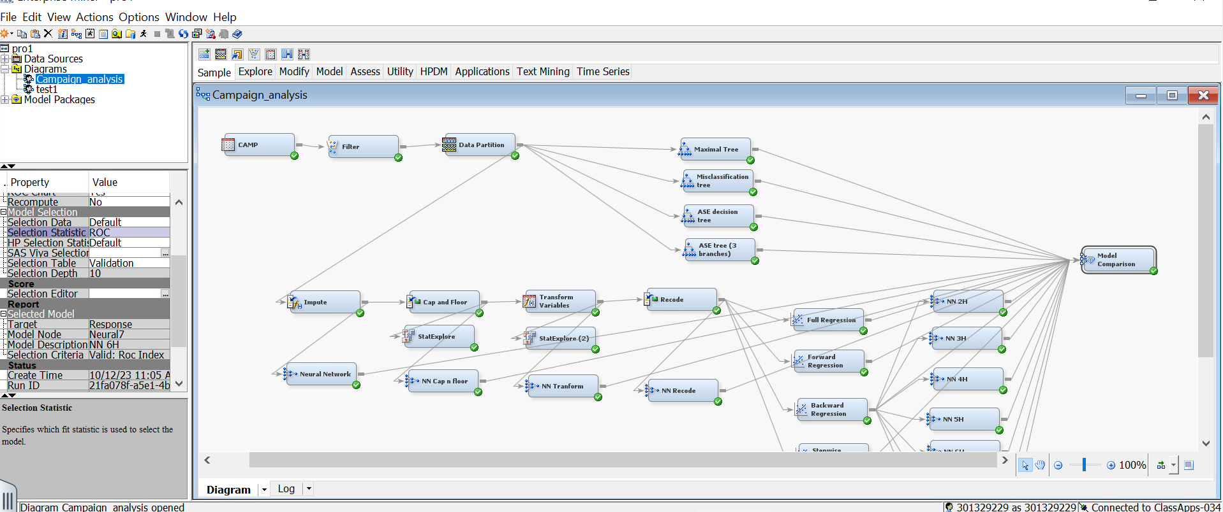

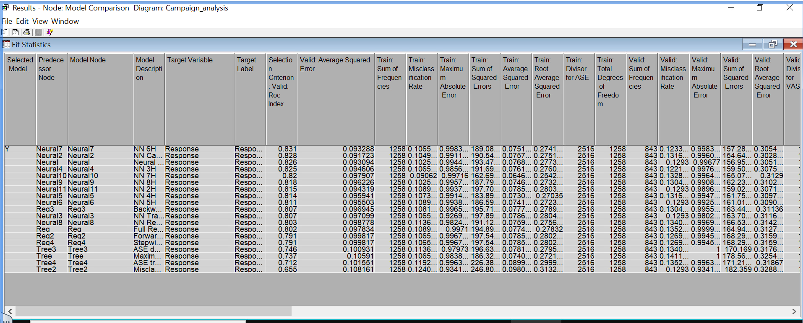

Below is the ROC plot that we got after running our model comparison node.

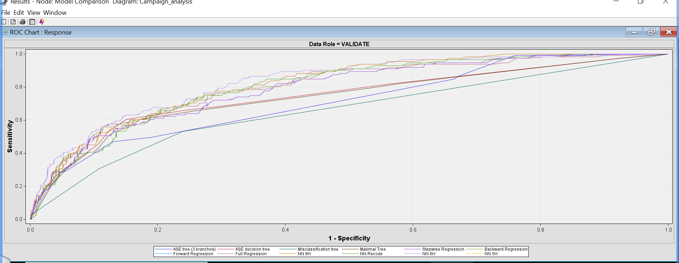

Below is the ROC curve for our newly introduced models:

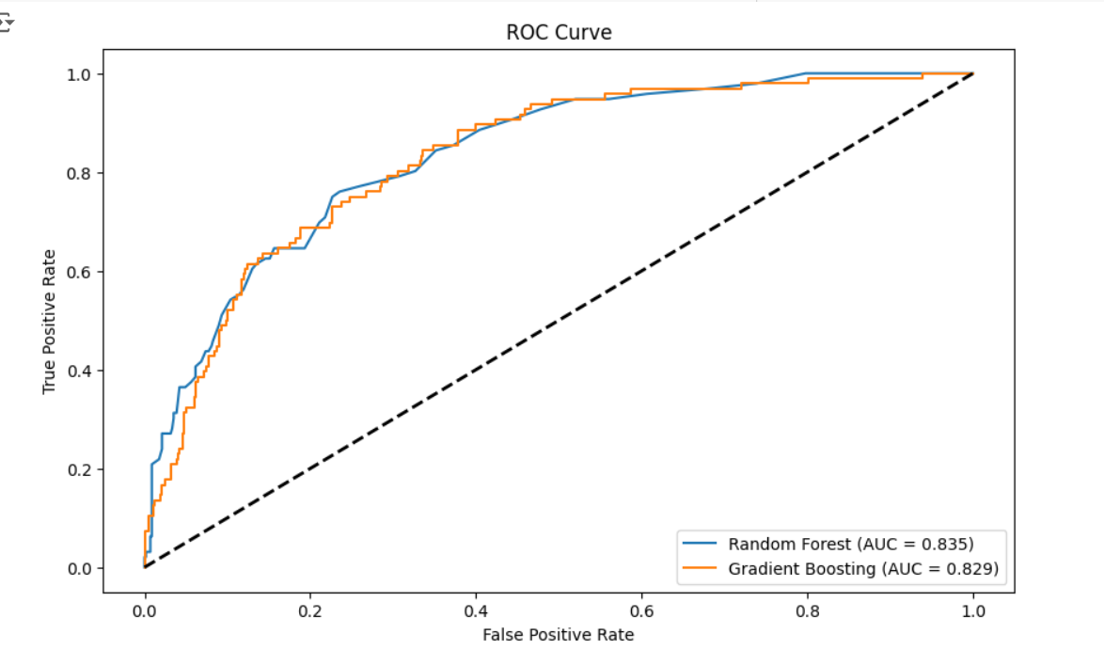

**Based on the ROC Index of all the models it can be deduced that the RANDOM FOREST with ROC index of 0.835 is our best model.**

# Conclusion

Throughout this report, we have tried to train the best predictive model that would help a company maximize its profit in the next marketing campaign. We have used different supervised machine learning models such as Decision Trees, Random forest,Regression, and Neural Networks in our study. From the detailed analysis, it can be inferred that the best model is the **RANDOM FOREST** because it has the highest ROC index.

The model that we trained is restricted to the people who spend less than or equal to $1000 in 2 years on wines. Based on our study we discovered that the likelihood of the acceptance of a campaign is influenced by various factors such as the amount spent on different product categories, marital status, purchase behaviours, and demographic characteristics. Based on these factors, we will be enumerating a list of suggestions that would provide further impetus to the marketing campaign.

# Recommendations

Based on the identified relationships between various factors and the likelihood of campaign acceptance, we derived the following actionable recommendations for the business:

* The business should lay more emphasis on promoting meat products as an increase in spending on these items significantly boosts the likelihood of campaign acceptance.
* Consider tailoring promotions for catalog purchases, as this category also shows a strong positive correlation with campaign acceptance.
* The business should consider targeted promotions or incentives for customers spending less than $14.5 on gold products as they are less likely to accept the campaign.
* The positive correlation between web visits and campaign acceptance suggests a potential for increased engagement through online channels. Therefore, the business should leverage online platforms by increasing digital marketing efforts.
* Consider the recency of customer interactions in campaign targeting. Frequent interactions and recent purchases may positively influence the likelihood of accepting the campaign.
* Reduce unnecessary spending towards non-responders, this will help save resources and helps the firm to focus on more promising segments.
* For customers identified as non-responders, consider revising the marketing messages or offers. Experiment with different content, offers, or channels to see if you can convert some of these non-responders into responders.
* Launch secondary campaigns targeting a random sample of customers not predicted to respond. This can help identify additional patterns and improve future models.
* Establish a feedback loop to monitor the performance of marketing campaigns and model predictions. Use this feedback to refine the model and improve its accuracy over time.
* Combine insights from the model with traditional marketing strategies to create a more holistic approach. For example, integrate online and offline data to get a complete view of customer behavior.

**References**

* Jensen, W. A. (2009). Data Mining Using SAS ® Enterprise Miner [Review of Data Mining Using SAS ® Enterprise Miner]. Technometrics, 51(1), 105–105. The American Society for Quality and The American Statistical Association.
* [Marketing Campaign (kaggle.com)](https://www.kaggle.com/datasets/rodsaldanha/arketing-campaign) (link for raw data)